**Deccan Education Society’s**

**Kirti M. Doongursee College of Arts, Science and Commerce [NAAC Accredited: “A Grade”]**



**T.Y.B.Sc. [Computer Science]**

**Practical Journal**

**USCSP601**

**Seat Number [681373]**

**Roll No:-34**

**Department of Computer Science and Information Technology**

**Department of Computer Science and Information Technology**

**Deccan Education Society’s**

**Kirti M. Doongursee College of Arts, Science and Commerce**

**[NAAC Accredited: “A Grade”]**

**C E R T I F I C A T E**

This is to certify that Ms. **Neha Ganesh Patil** of T.Y.B.Sc. (Computer  Science) with seat no. 681373 & roll no. **34** has completed 10 practicals of Paper- USCSP601 under my supervision in this College during the year 2021-2022.

**Lecturer-In-Charge                                                          H.O.D.**

**Department of**

**Computer Science & IT**

Date: / /2021

**Examined by:                                                         Remarks:**

| **DATE** | **TOPIC** | **SIGNATURE** |
| --- | --- | --- |
|  | **Practical 1 :**  Creating a Forensic Image using FTK Imager/Encase Image:  - Creating Forensic Image  - Check Integrity of Data  - Analyze Forensic Image |  |
|  | **Practical 2:**  Data Acquisition:  Extract Images, Text files from RECYCLER and unallocated space using FTK Imager |  |
|  | **Practical 3:**  Forensics Case Study:  - Solve the Case study (image file) using Autopsy |  |
|  | **Practical 4:**  Capturing and analyzing network packets using Wireshark |  |
|  | **Practical 5:**  Analyze the packets provided in lab and solve the questions using Wireshark |  |
|  | **Practical 6:**  Using Sysinternals tools for Network Tracking and Process Monitoring |  |
|  | **Practical 7:**  Recovering and Inspecting deleted files |  |
|  | **Practical 8:**  Acquisition of Cell phones and Mobile devices |  |
|  | **Practical 9:**  Email Forensics |  |
|  | **Practical 10:**  Web Browser Forensics |  |

**Practical 1**

1. **Creating Forensic Images FTK**

To create a forensic image:

1. Click File, and then Create Disk Image, or click the button on the tool bar.

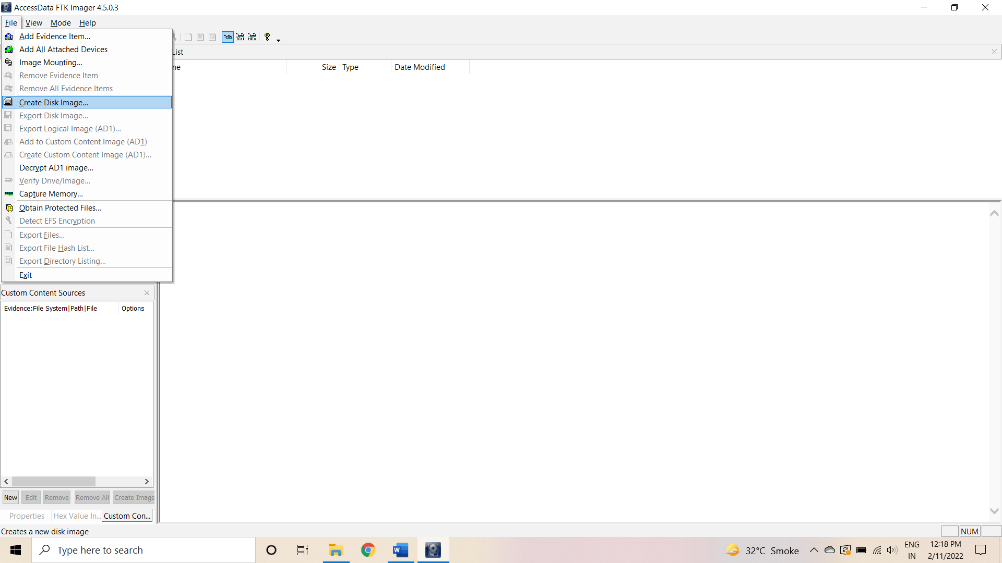

1. Select the source you want to make an image of and click Next.

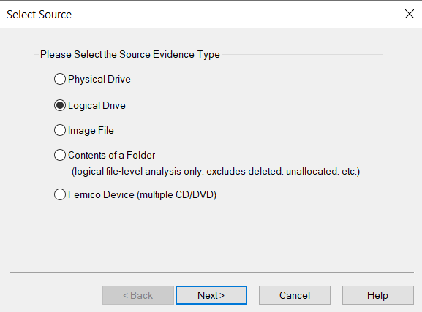

1. Select the drive or browse to the source of the image you want, and then click Finish.

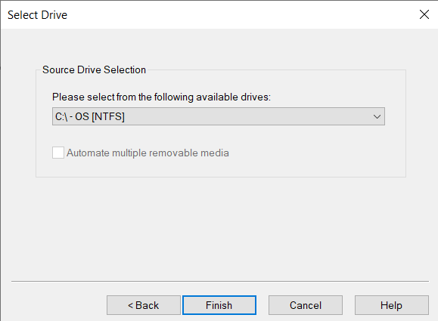

1. In the Create Image dialog, click Add.

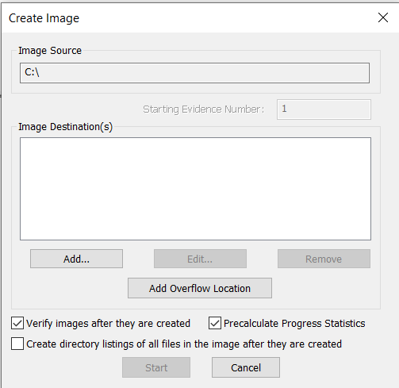

1. Select the type of image you want to create, and then click Next.

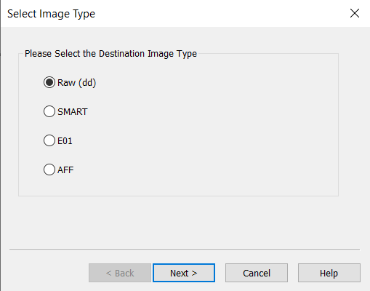

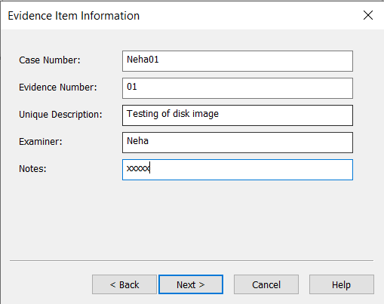

1. In the Image Destination Folder field, type the location path where you want to save the image file, or click **Browse** to find to the desired location.

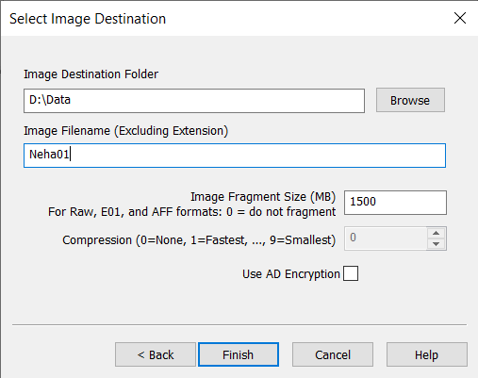

1. In the Image Filename field, specify a name for the image file but do not specify a file extension.
2. In the Image Fragment Size field, specify the maximum size in MB for each fragment of the image file. The s01 format is limited by design to sizes between 1 MB and 2047 MB (2 GB). Compressed block pointers are 31- bit numbers (the high bit is a compressed flag), which limits the size of any one segment to two gigabytes.
3. Click **Finish**. You return to the Create Image dialog.

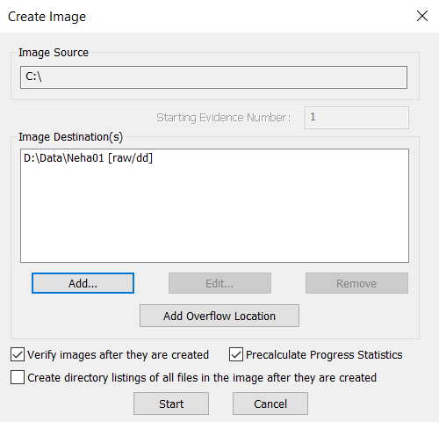

1. To add another image destination (i.e., a different saved location or image file type), click **Add**, and repeat steps 5– 10. To make changes to an image destination, select the destination you want to change and click **Edit.**

To delete an image destination, select the destination and click **Remove**.

1. Click **Start** to begin the imaging process. A progress dialog appears that shows the following:

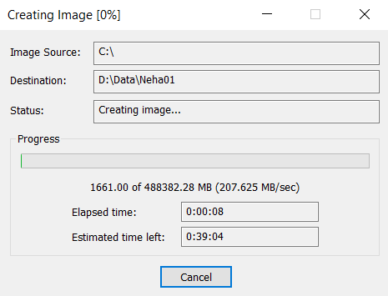

1. After the images are successfully created, click Image Summary to view detailed file information, including MD5 and SHA1 checksums.

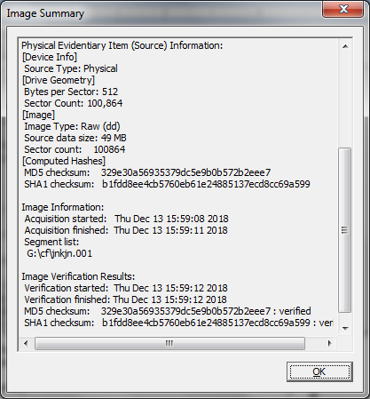

1. When finished, click **Close**
2. **Analyze Forensic Image:**

1. Click on Add Evidence Item to add evidence from disk, image file or folder.

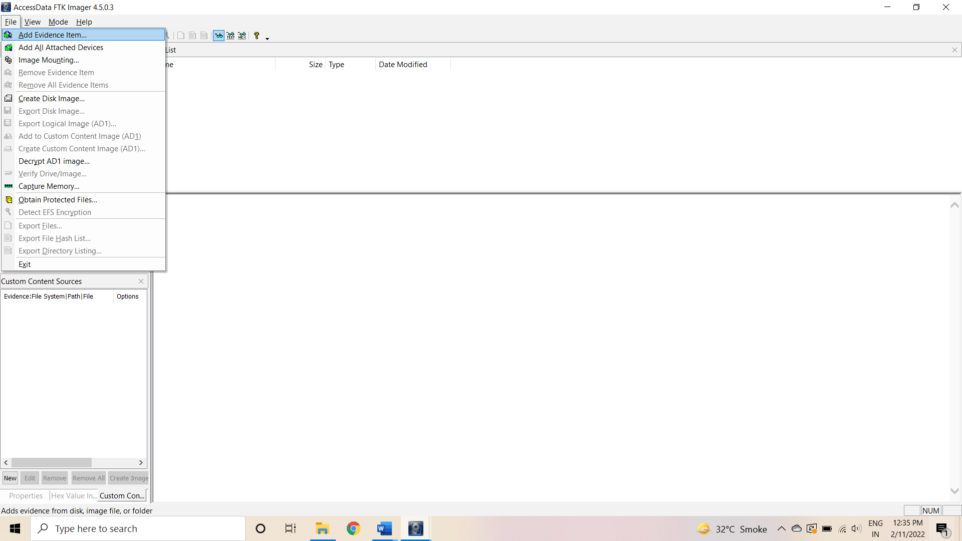

2. Now select the source evidence type as physical drive, logical drive or image file. We have selected image file and click on next.

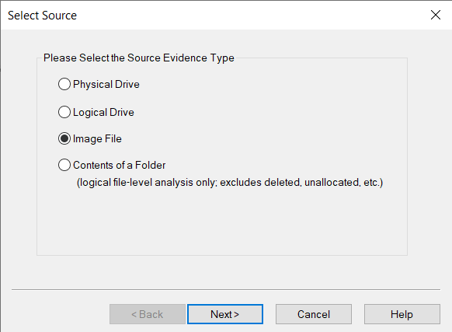

3. Select virtual drive image & click on open option. Select the source path and click on finish.

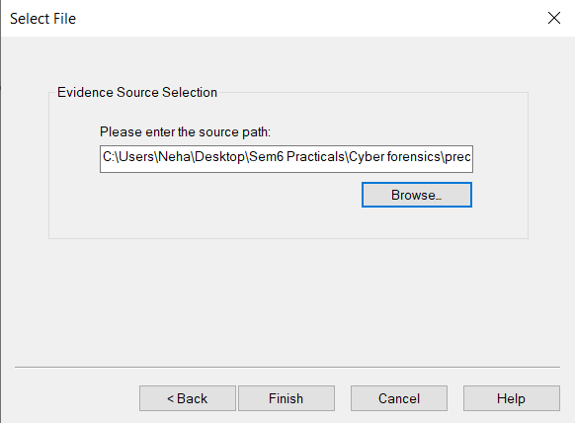

4. Now select Evidence Tree and analyze the virtual disk as physical disk.

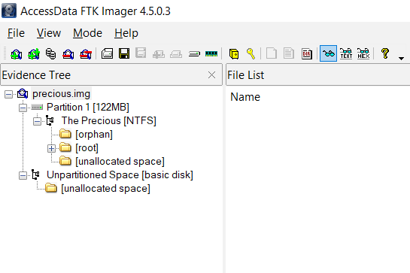

5. Here we can analyze disk image by noticing these items:

In the left pane, a tree-structured list of the contents of C drive appears

* $Extend and system volume information contains NTFS file system data which would be tedious to analyze
* RECYCLER contains files in the recycle bin
* Unallocated space contains files which are deleted
* We can analyze different types of files such as images, pdf, docx, html, txt, log files etc.,

html file from RECYCLER

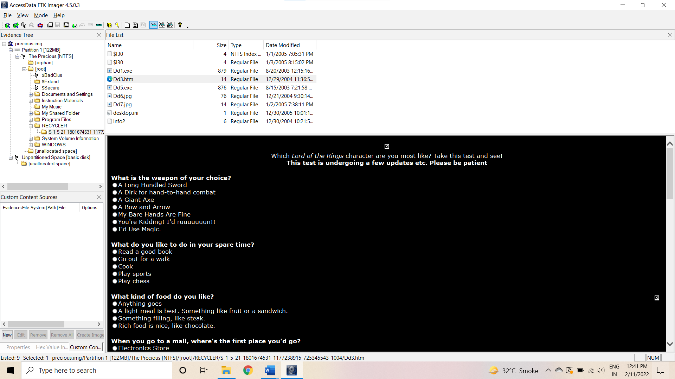

Image file from RECYCLER

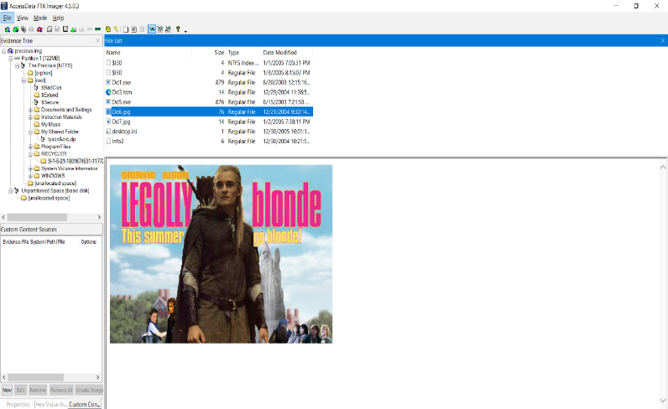

PDF file from document & settings folder

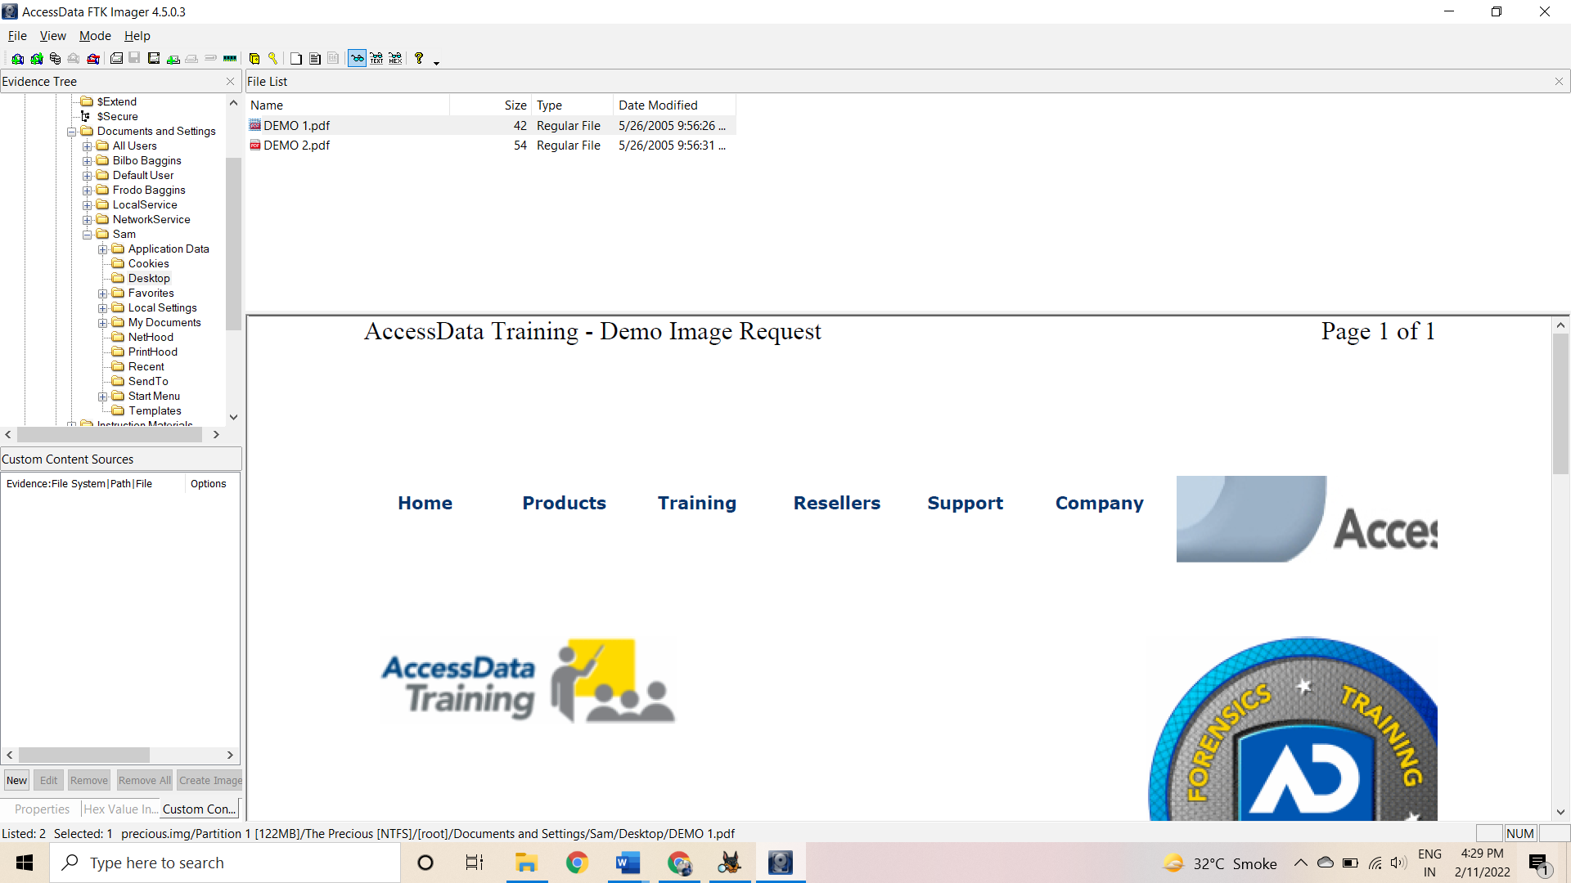

**c) Extract Images, Text files from RECYCLER and unallocated space using FTK Imager**

1. View Deleted File(s) in the Recycler. Navigate to RECYCLER --> RECYCLER SUBDIR Click on the jpg file if it exists.

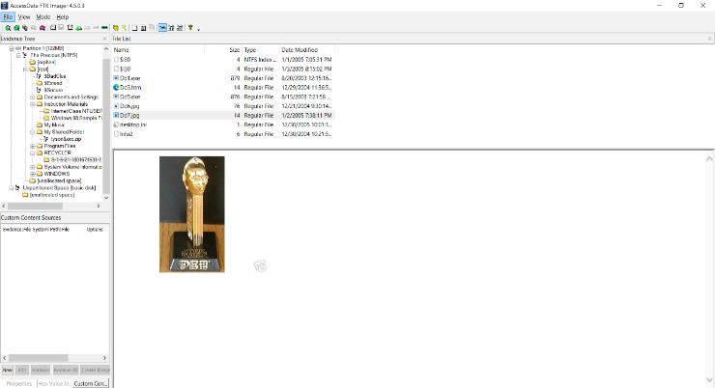

2. Recover deleted image using option Export File. Right Click on the file that contains the picture Select Export Files

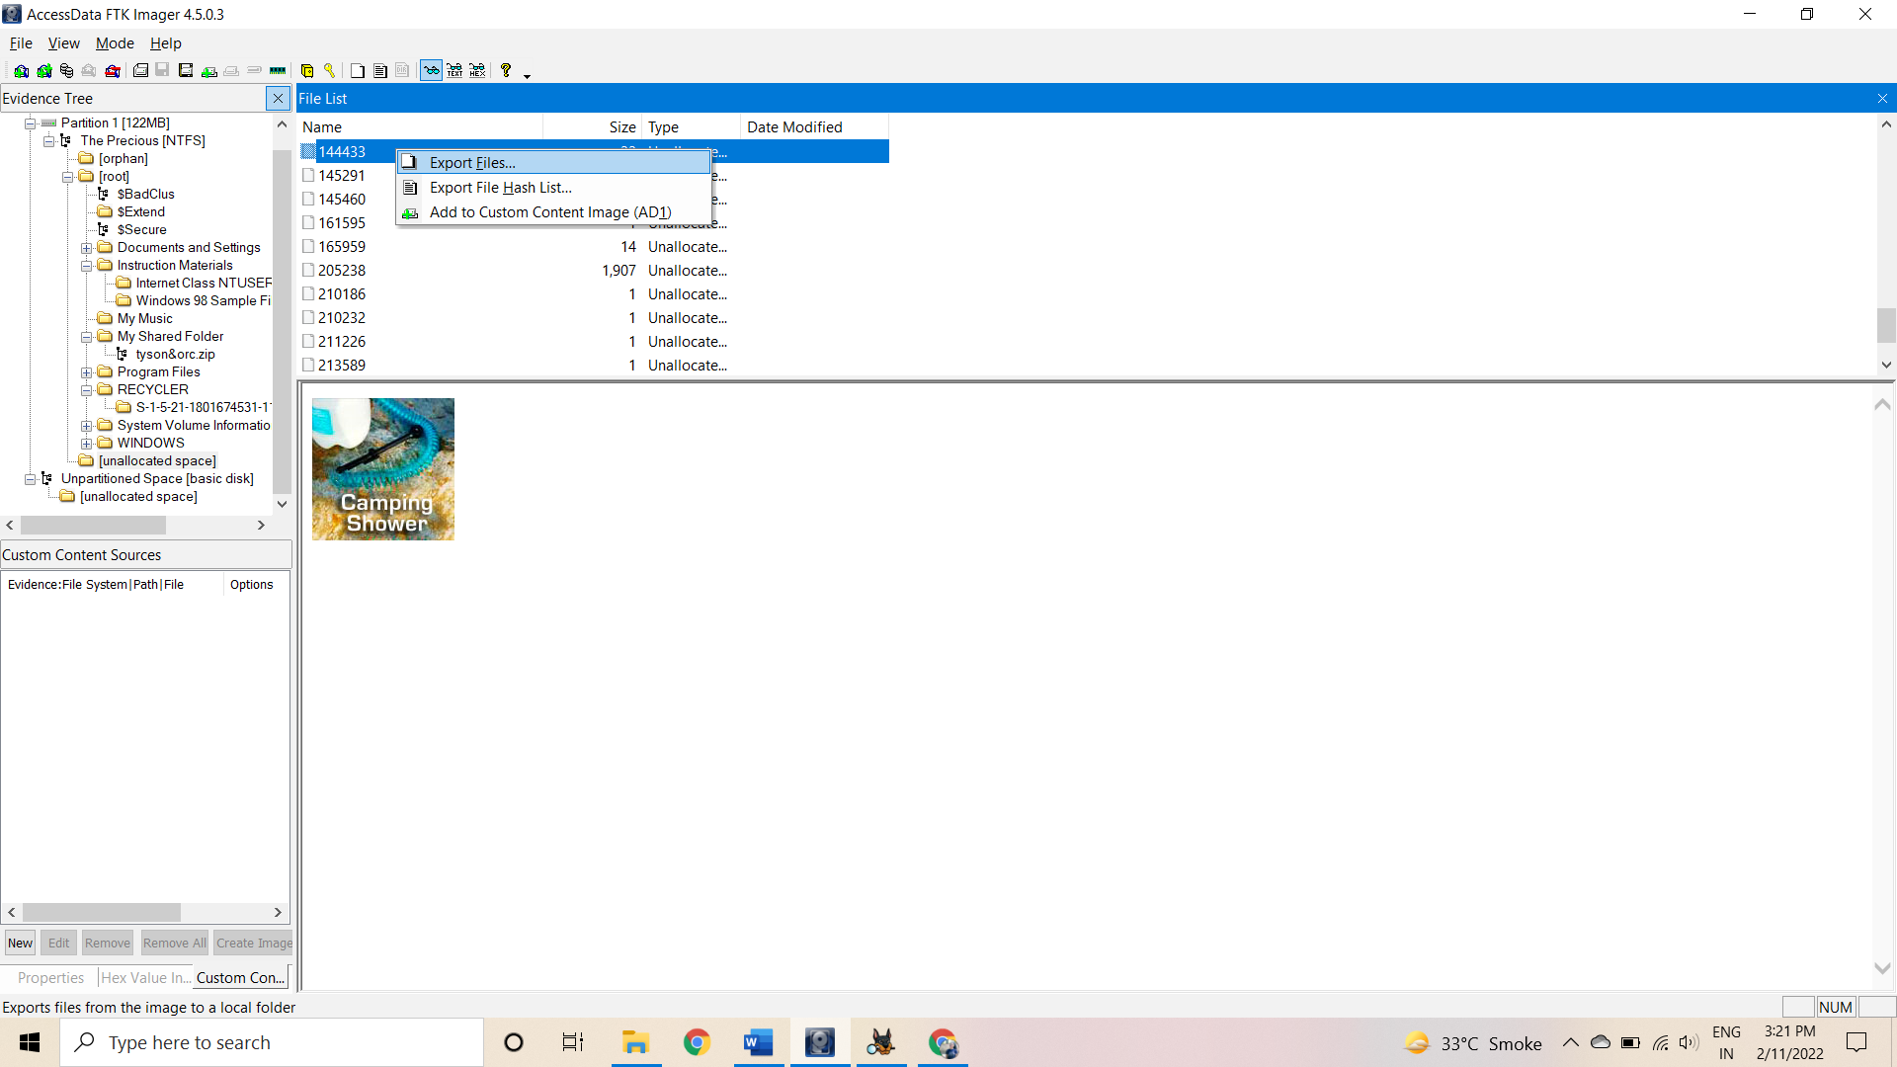

3. Select the destination folder Navigate to C:\Users\Neha\Desktop\Sem6 Practicals\Cyber forensics. Click the OK Button.

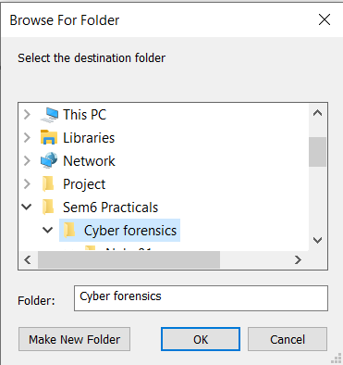

4. Export Results Click the OK Button

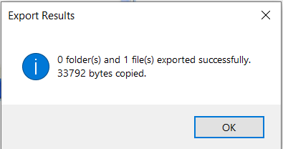

5. View recorded picture. Rename File

* 1. Navigate to C:\Users\Neha\Desktop\Sem6 Practicals\Cyber forensics
  2. Right Click on the filename that contain all numbers In my case the filename is 144433.
  3. Click Rename

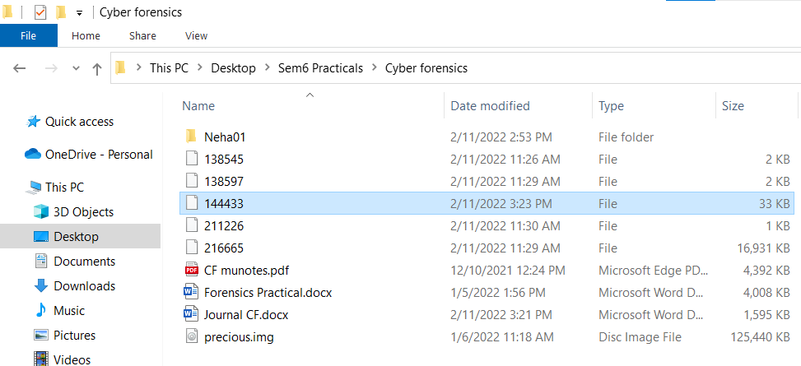

6. Rename file to "shower.jpg"

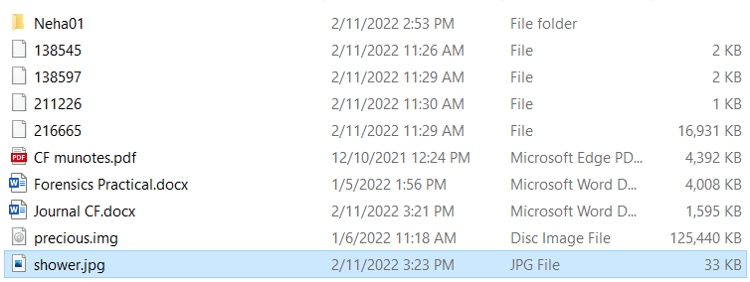

7. Open File

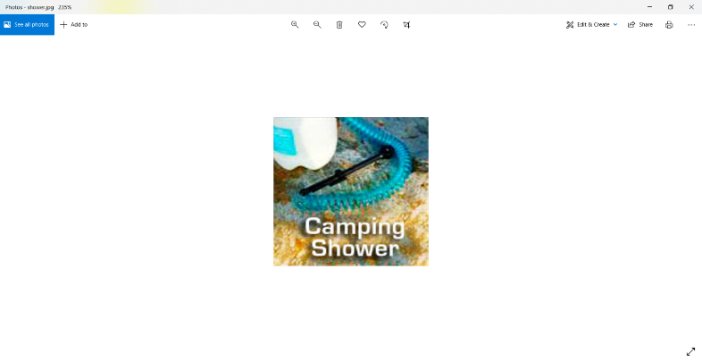

**Practical 2**

**AIM: Perform data acquisition using: ProDiscover**

## Steps:

1. First Open Prodiscover Basic and start with new case

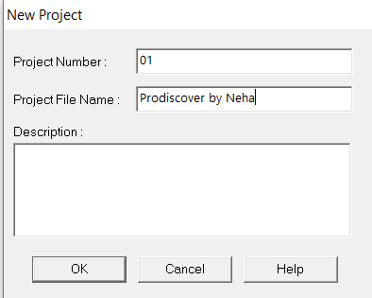

2. created project appears in left pane and select add>image file 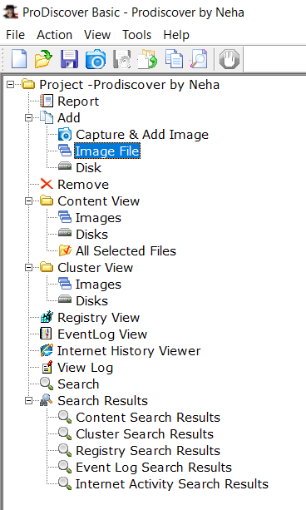

3. Open the image exported, go to Add > Images in left pane.

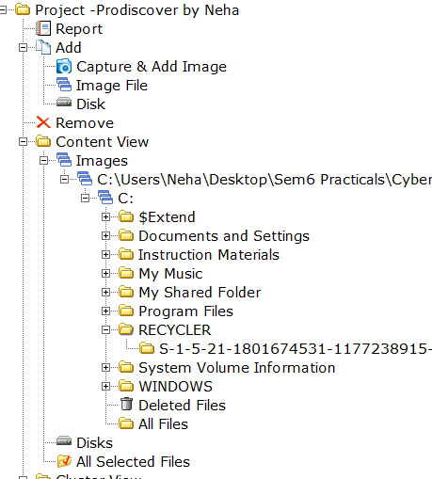

4. Click on any File and type a comment.

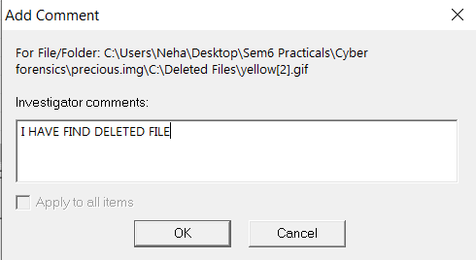

5. the cluster view is seen from the cluster view in left panel.

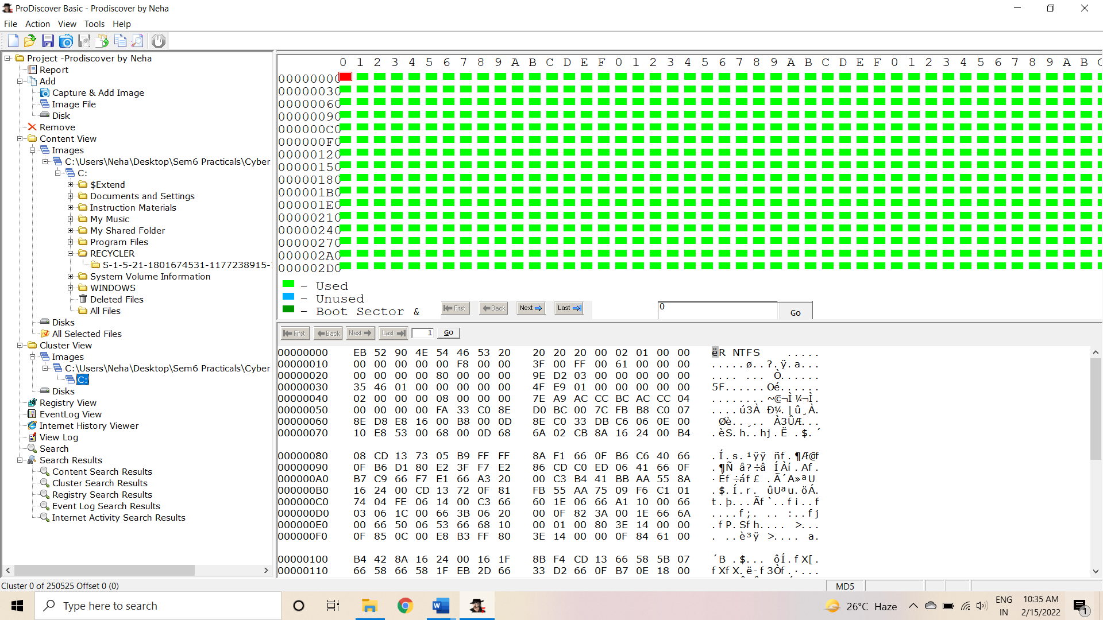

6. We can also view gallery view by Right Click.

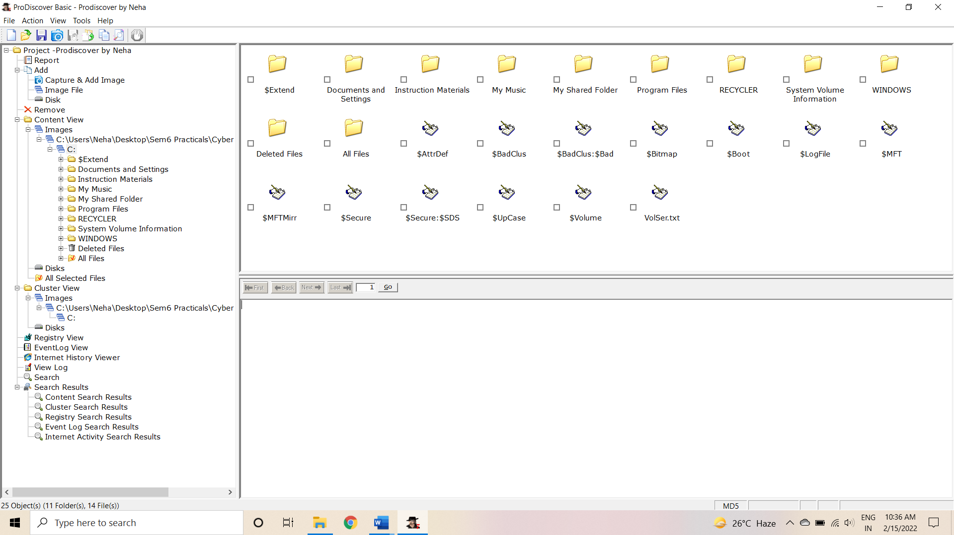

7. Keyword search. Click on Search in left pane and Enter the file name to be searched in the image created.

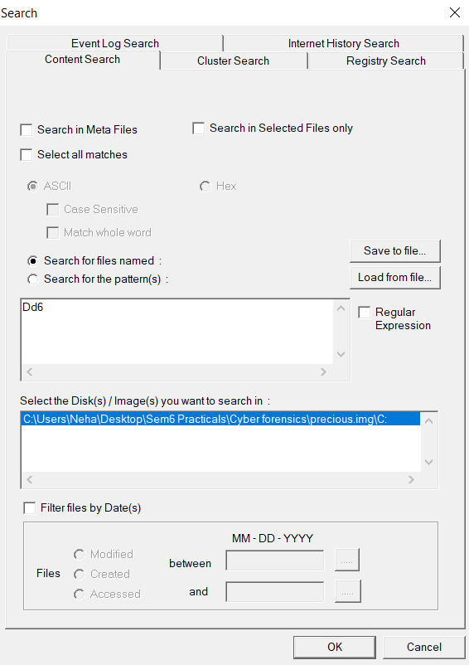

Step 8: Output of Keyword search.

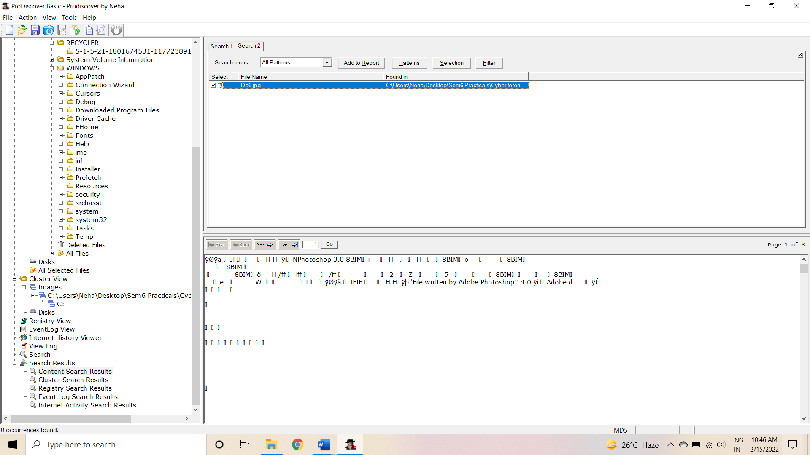

Step 11 : Click on View>Report.

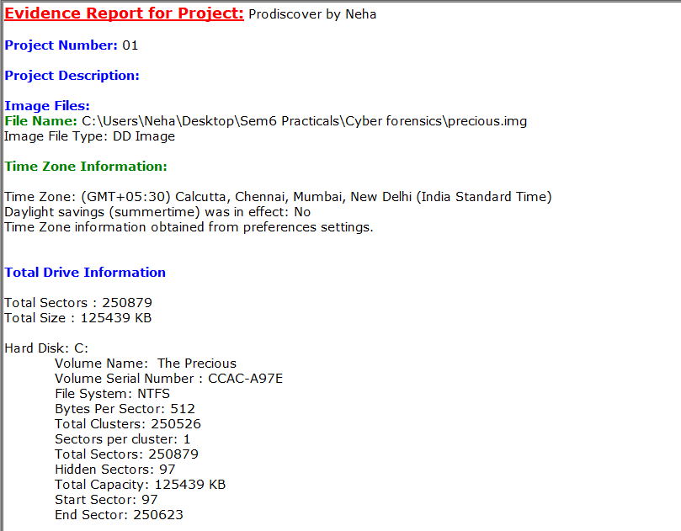

**Practical 3**

**AIM: Forensics Case Study: - Solve the Case study (image file) using Autopsy**

1. To create a case, use either the “Create New Case” option on the Welcome screen or from the “File” menu. This will start the **New Case Wizard**. Select new case

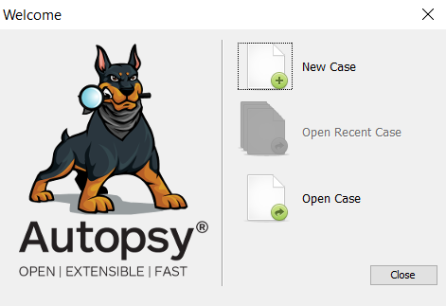

2.You will need to supply it with the name of the case and a directory to store the case results into. Type the case name as Neha01 and select the base directory as C:\Users\Neha\Desktop\Sem6 Practicals\Cyber forensics\

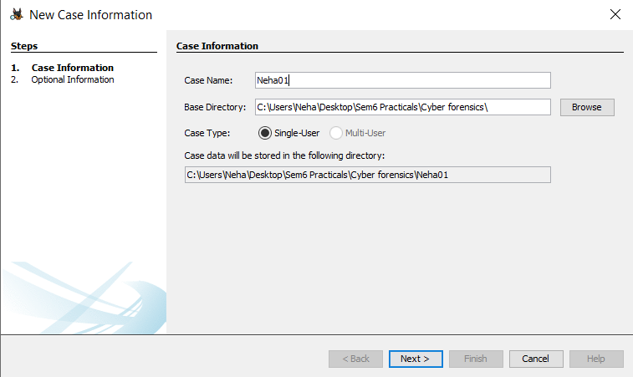

1. You can optionally provide case numbers and other details

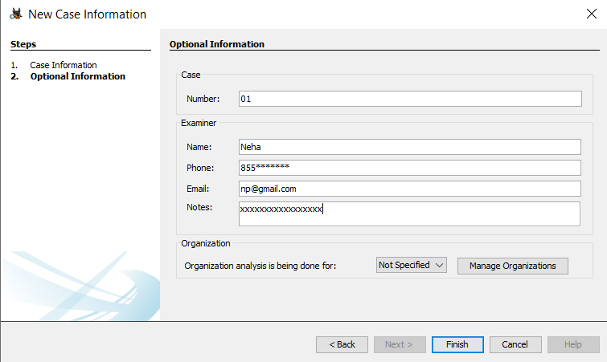

1. After adding case information it will automatically redirect to add data source wizard Click on next

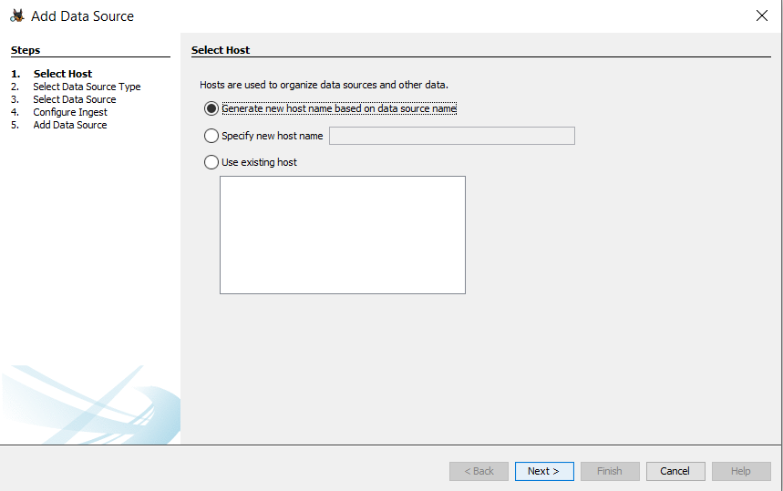

1. You will need to choose the type of input data source to add (image, local disk or logical files and folders). Click on disk image or VM file then click on next

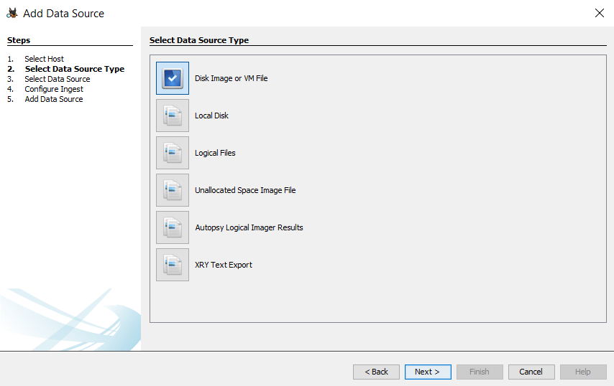

6. Next, supply it with the location of the source to add.

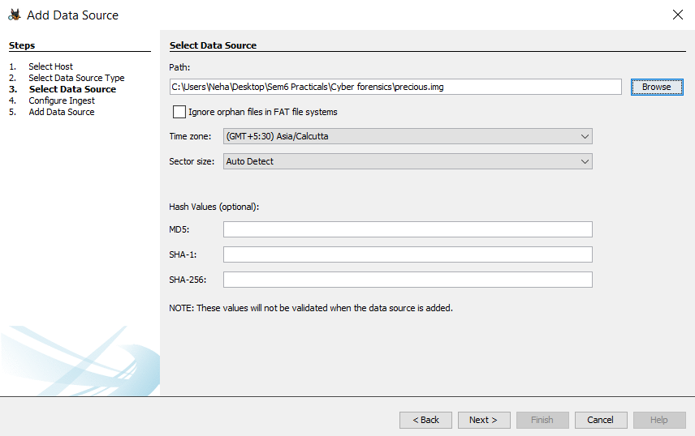

## 7. Ingest Modules

You will next be prompted to configure the Ingest Modules. Ingest modules will run in the background and perform specific tasks Click on next

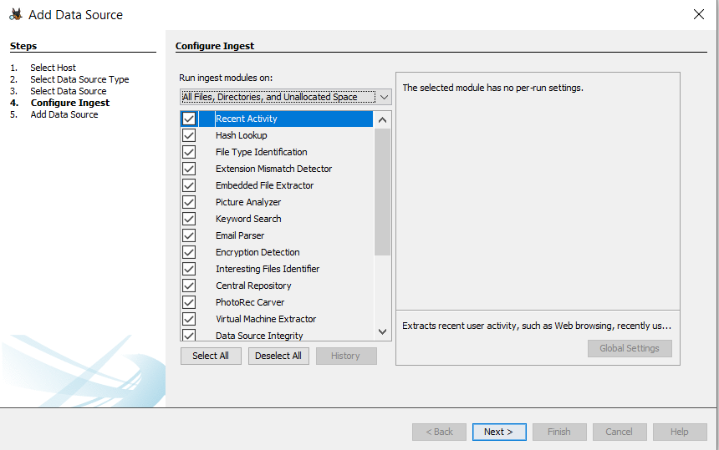

Autopsy will start to analyze these data sources and add them to the case and internal database

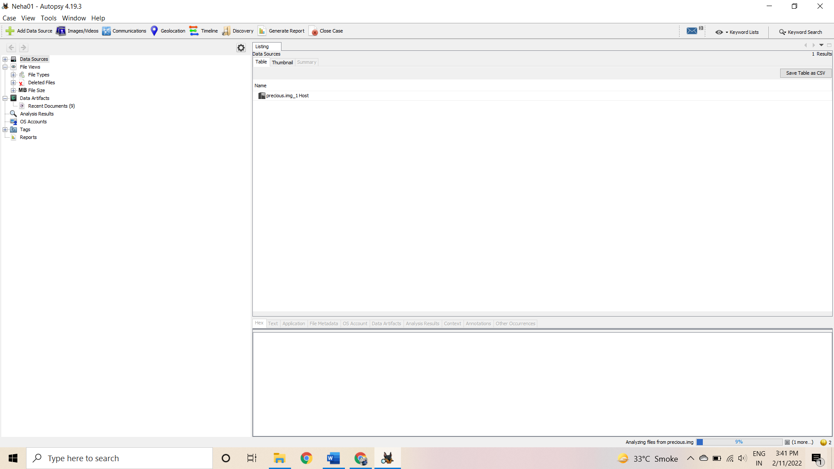

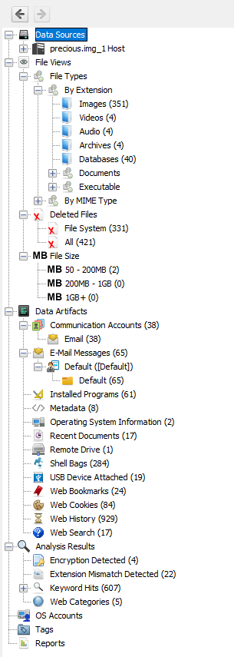

1. Click on deleted files < file system select first image

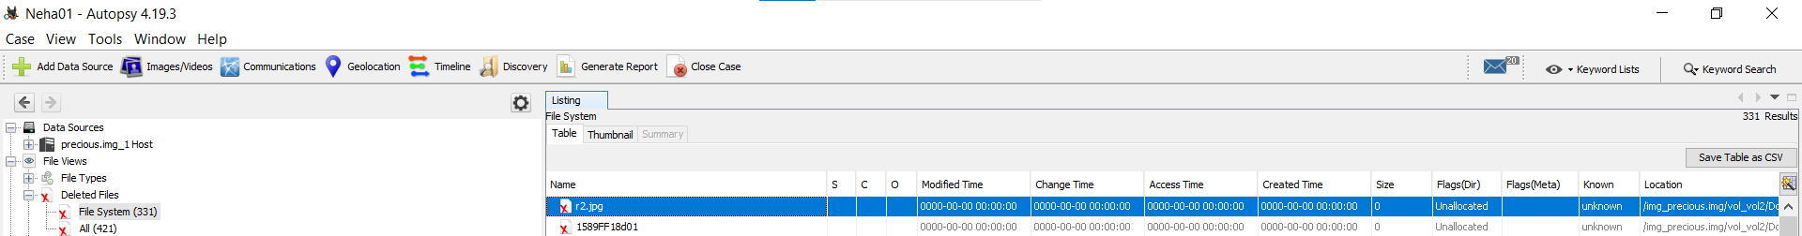

1. You can see metadata of image file

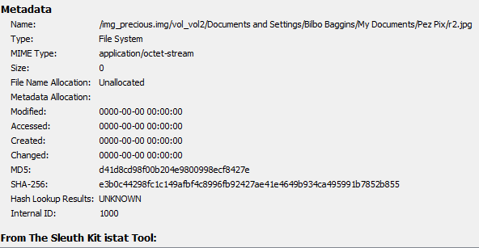

1. A final report can be generated that will include all analysis results. Use the “Generate Report” button to create this. It will create an HTML or XLS report in the Reports folder of the case folder.

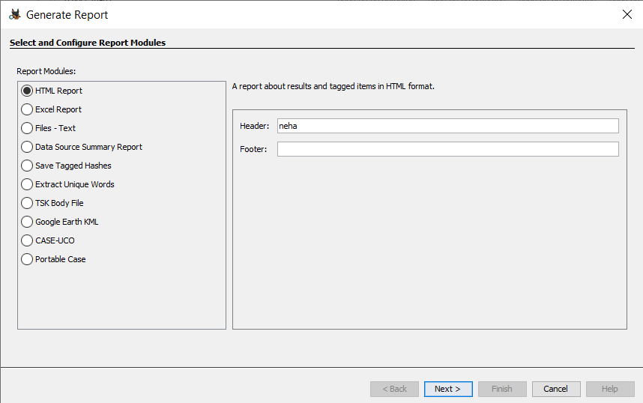

16. click on check box then click on next

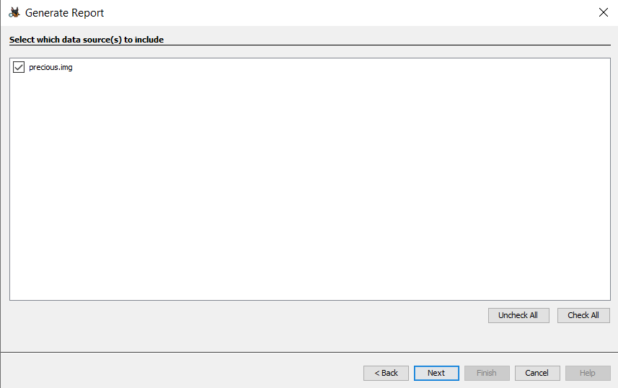

17.Click on all results radio button

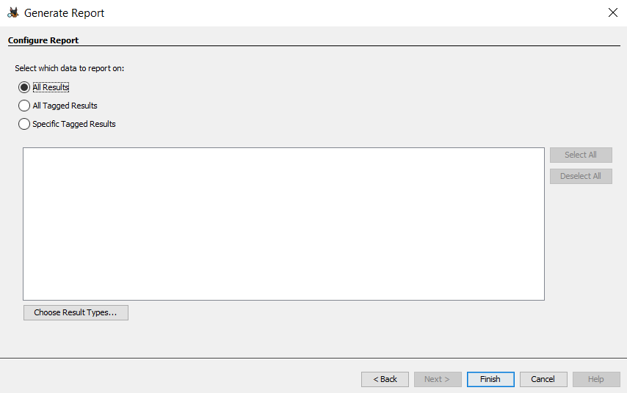

18. Html report is generated click on link it will redirect to browser

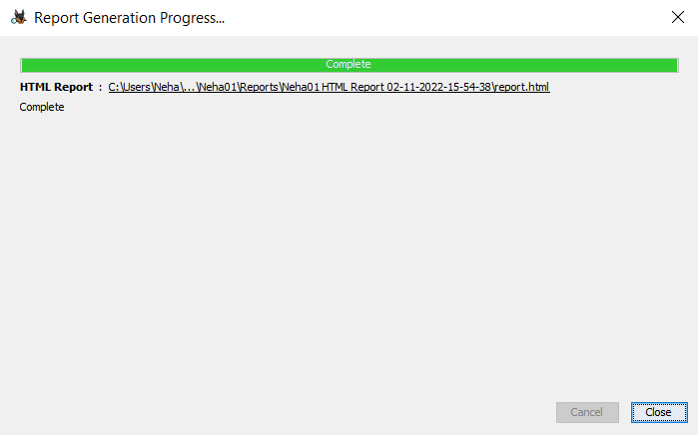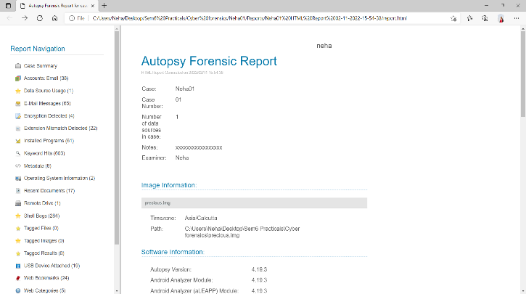

19. Click on pdf from left pane select demo2 pdf and analyze it

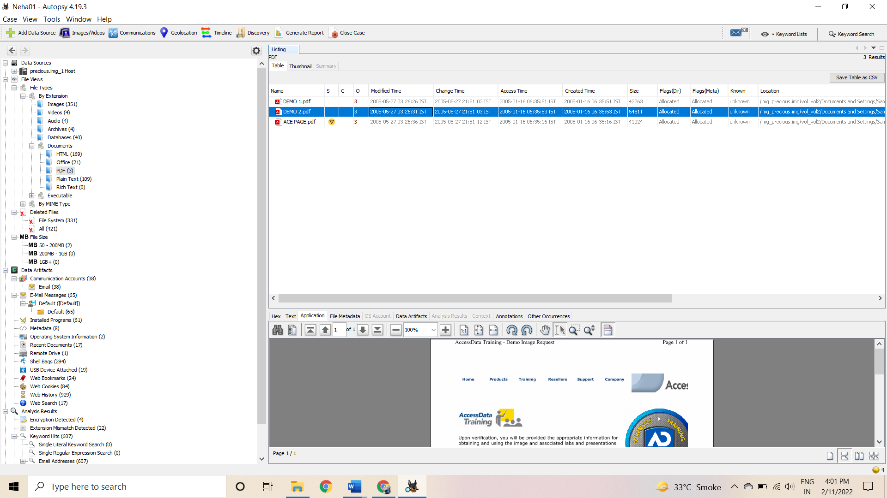

Metadata and data artifacts to show how relevant it is to the investigation.

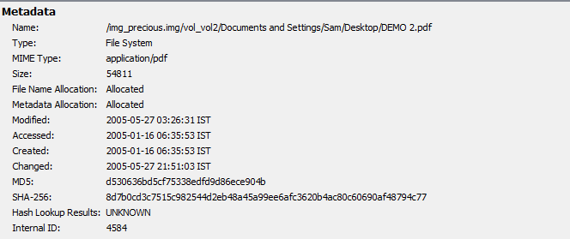 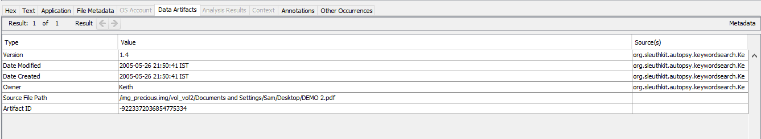

**Practical 4**

## AIM: Capturing and analyzing network packets using Wireshark (Fundamentals) :

## - Identification the live network

## - Capture Packets

## - Analyze the captured packets

## Capturing Packets

## Capture traffic on your wireless network, click your wireless interface.

You can configure advanced features by clicking Capture>Options, but this isn’t necessary for now.

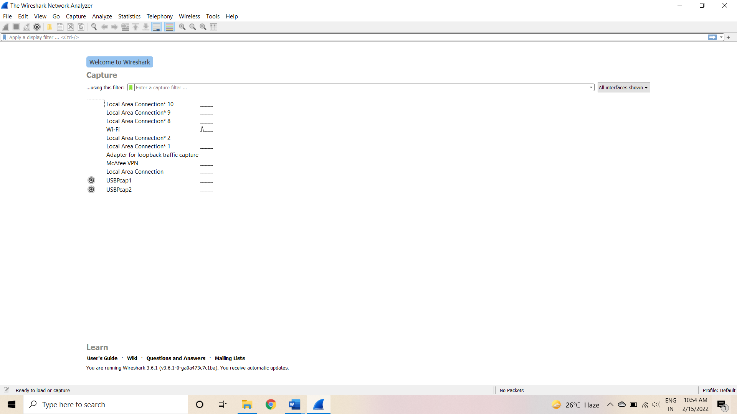

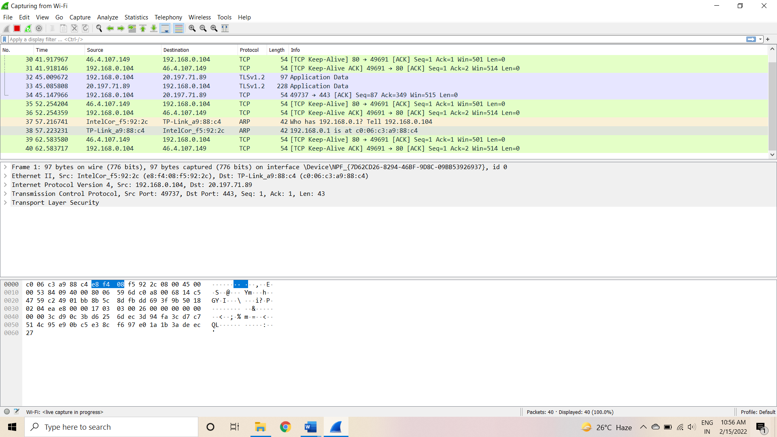

The red box button “STOP” on the top left side of the window can be clicked to stop the capturing of traffic on the network.

## Color Coding

Different packets are seen highlighted in various colors. This is Wireshark’s way of displaying traffic to help you easily identify the types of it. Default colors are:

Light Purple color for TCP traffic Light Blue color for UDP traffic

Black color identifies packets with errors – example these packets are delivered in an unordered manner.

To check the color coding rules click on View and select Coloring Rules. These color coding rules can be customized and modified to fit your needs.

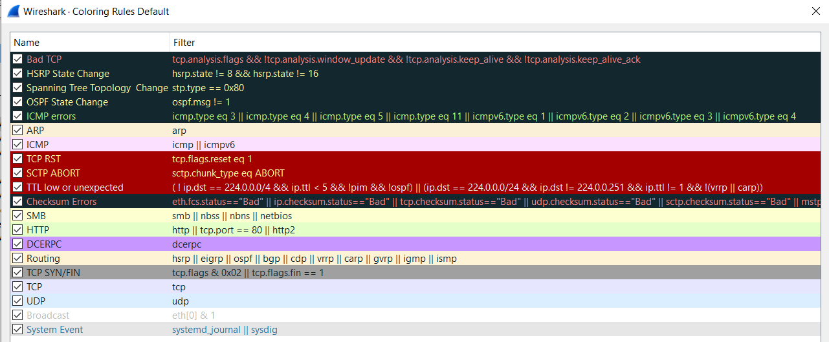

Analyze the captured Packets:

First of all, click on a packet and select it. Now, you can scroll down to view all its details.

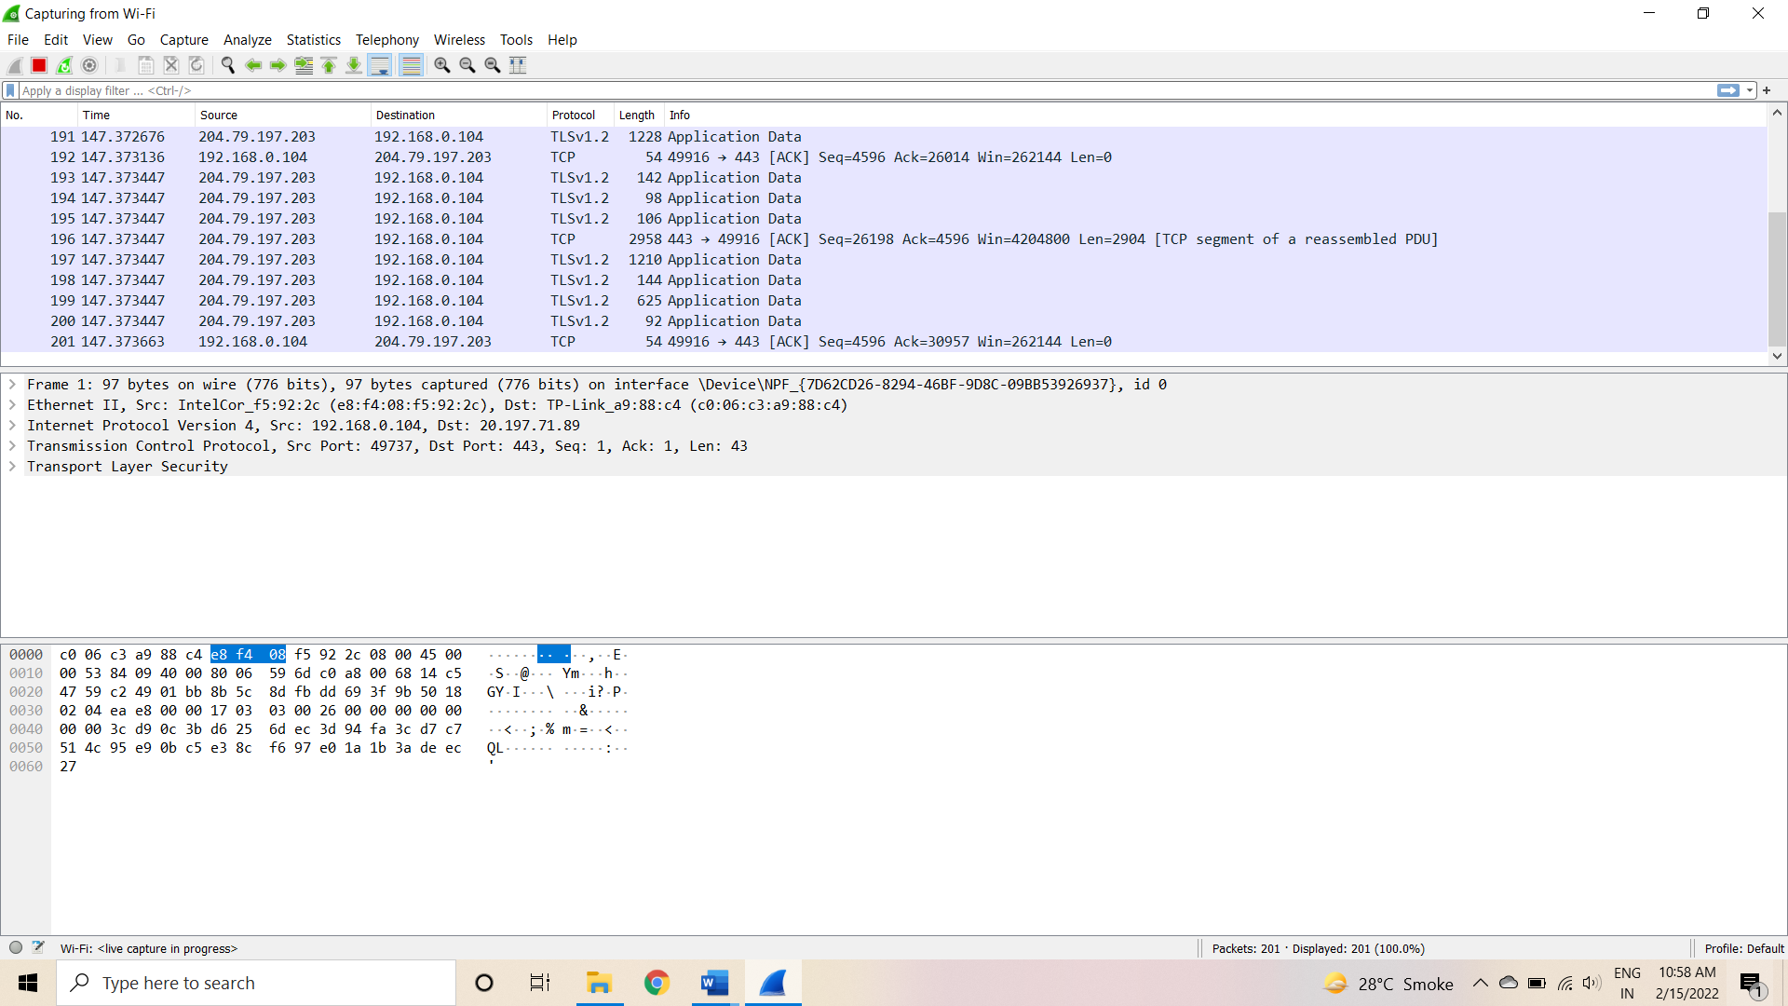

Filters can also be created from here. Right-click on one of any details. From the menu select Apply as Filter drop-down menu so filter based on it can be created.

Display filter command –

1. Display packets based on specific IP-address: **ip.addr ==192.0.2.1**

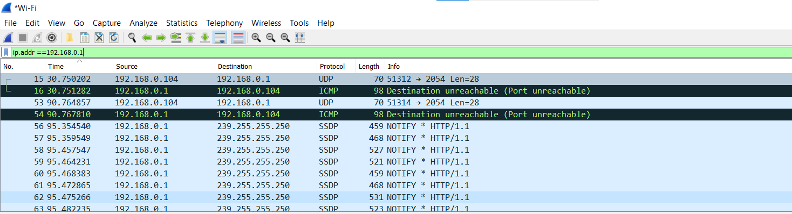

1. display packets which are coming from specific IP-address : **ip.src ==192.168.1.3**

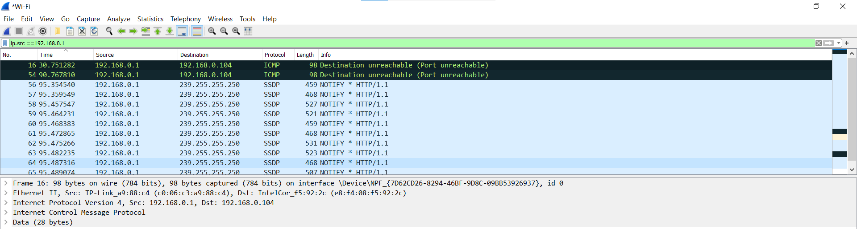

1. Display packets which are having specific IP-address destination :**ip.dst ==192.168.1.1**

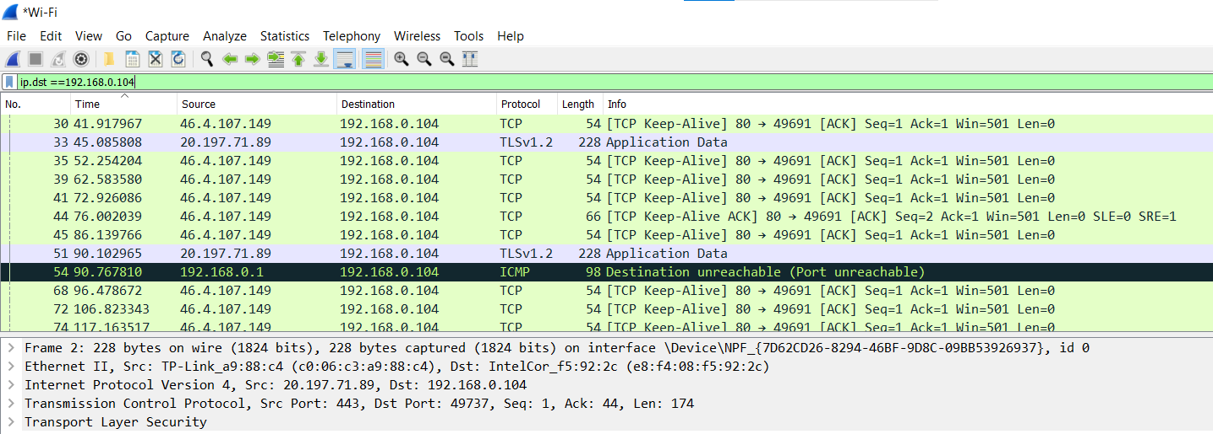

1. Display packets which are using http protocol : **http**

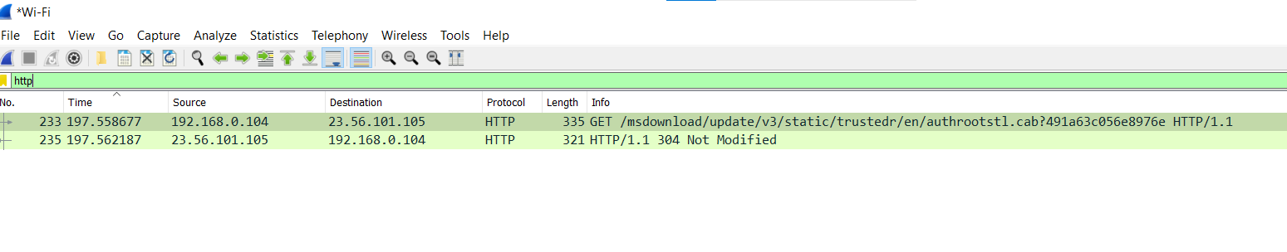

1. Display packets which are using http request : **http.request**

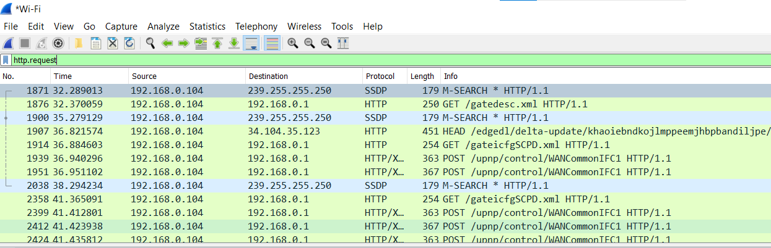

1. Display packets which are using TCP protocol : **Tcp**

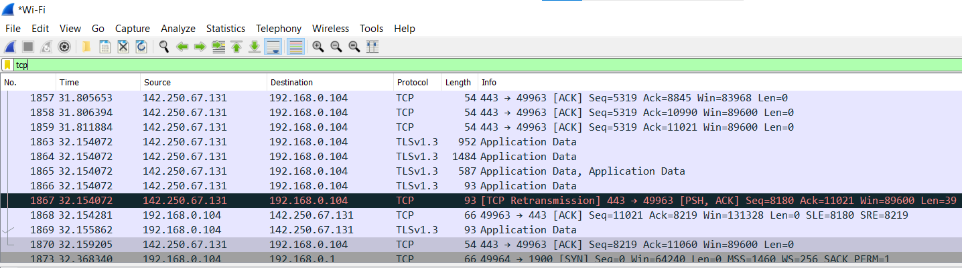

1. Display packets having no error connecting to server **http.response.code==200**

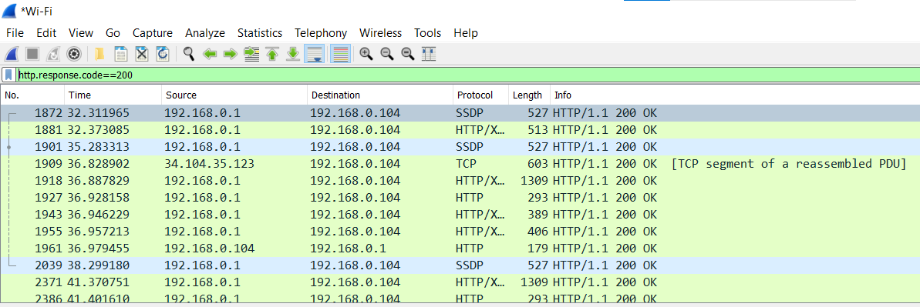

1. Display packets having port number80 : **tcp.port==80 ||udp.port==80**

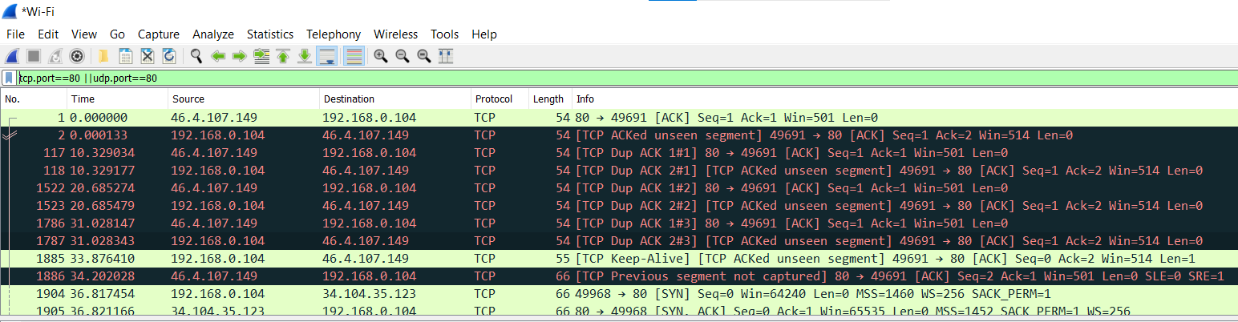

1. Display packets which that contains keyword facebook : **tcp contains facebook**

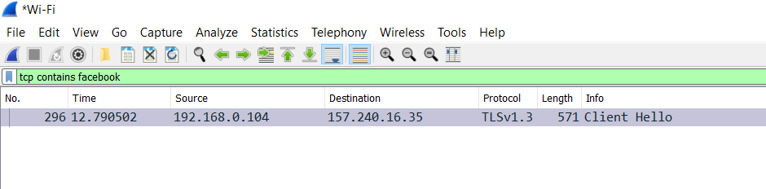

**Practical 5**

**AIM :- Analyze the packets provided in lab and solve the questions using Wireshark :**

* What web server software is used by [www.snopes.com?](http://www.snopes.com?)
* About what cell phone problem is the client concerned?
* According to Zillow, what instrument will Ryan learn to play?
* How many web servers are running Apache?

## What web server software issued by [www.snopes.com?](http://www.snopes.com?)

**Analysis –** The domain name be found from host header so we will set host header column where we will see all domain name. Select any HTTP request and expand the Hypertext Transfer Protocol then right click on Host header and then Apply as Column.

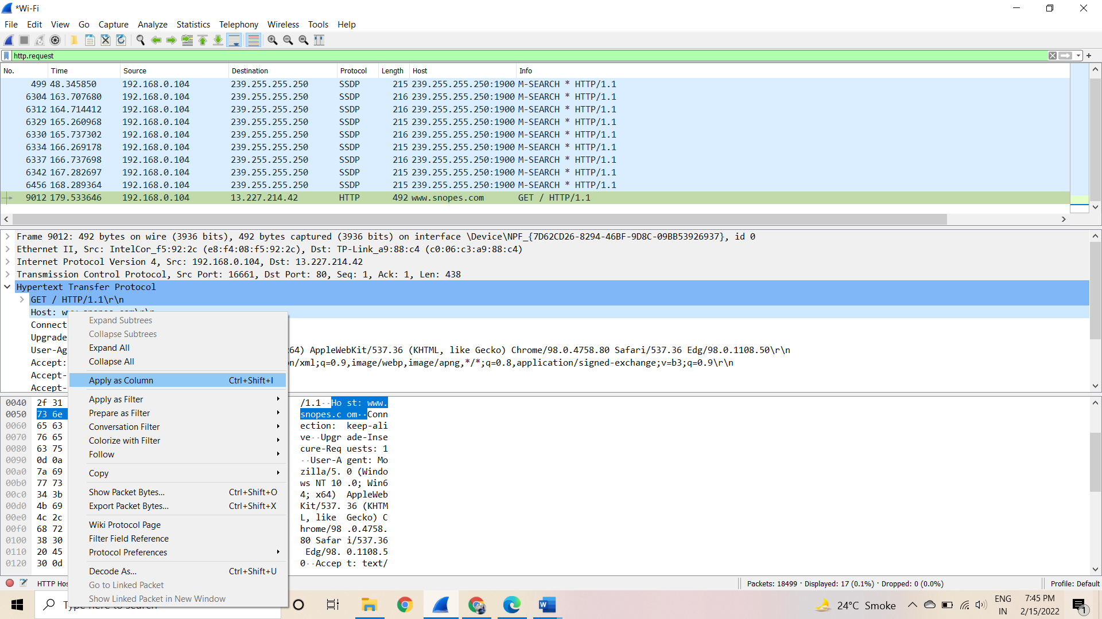

Now we can see our host [www.snopes.com](http://www.snopes.com/) in host column.

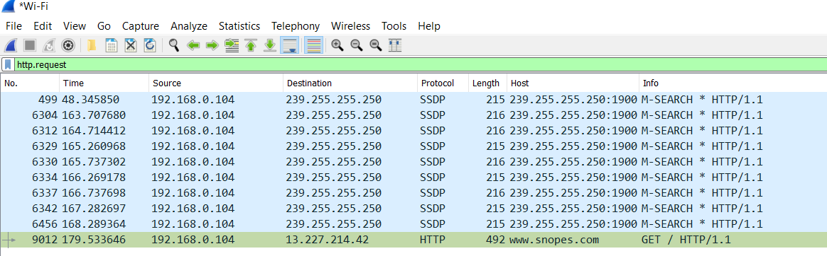

Right click on the selected packet and then select Follow TCP stream.

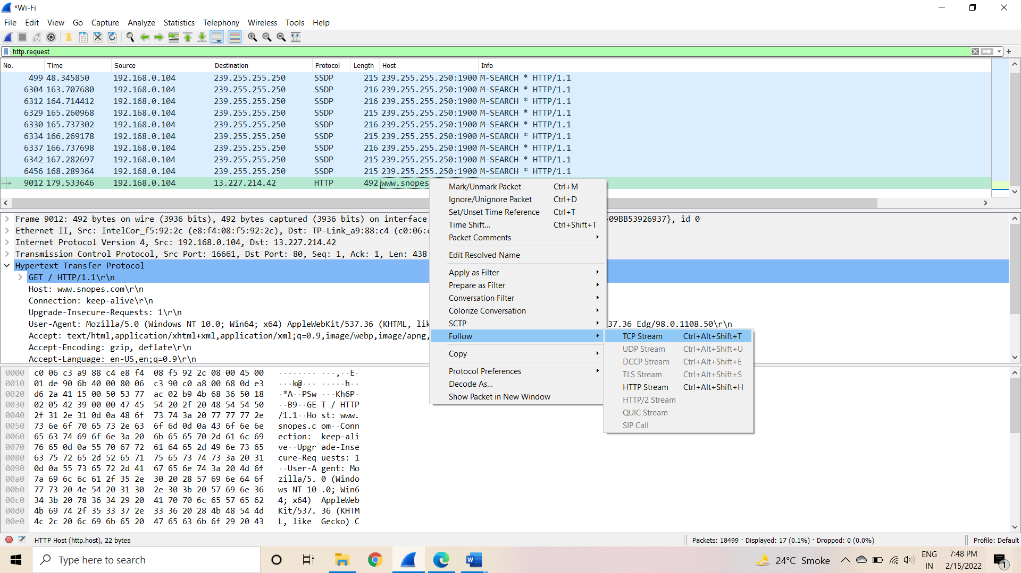

Now we can see the webserver name in server header it is CloudFront

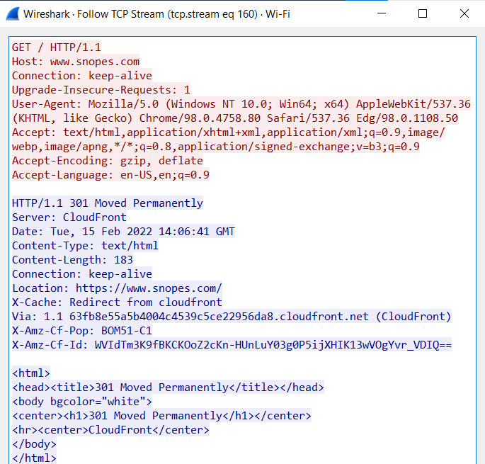

## About what cell phone problem is the client concerned?

**Analysis –** Client talking about cell so we search for cell keyword in whole packets. We will use regular express for searching the cell keyword. Apply frame matches “(?!) cell”

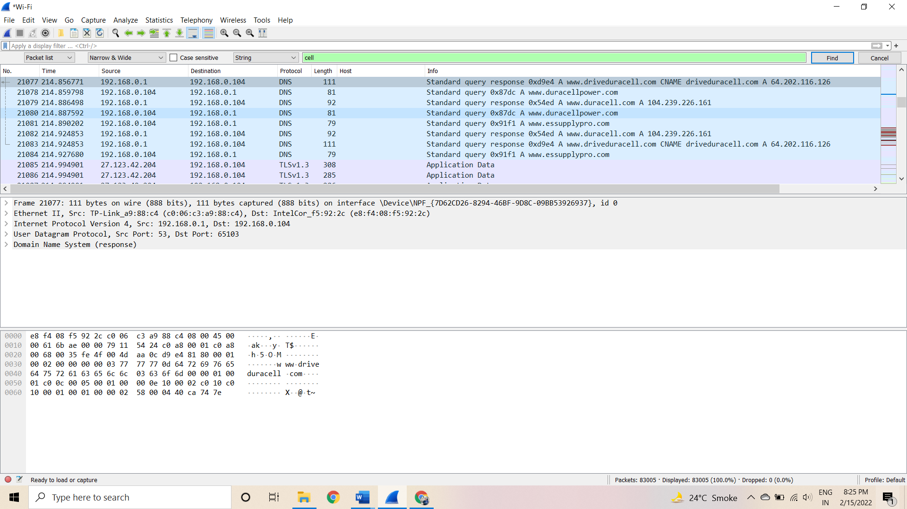

After applying the filter now, we will start to check every HTTP request. We noticed in the first HTTP request cell keyword is in URL and it was about cell phone charging issue.

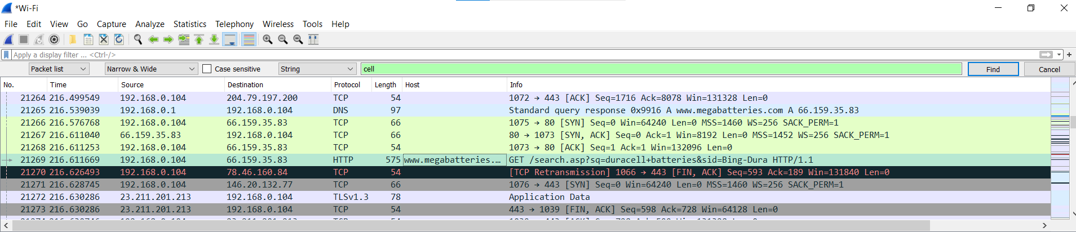

## According to Zillow, what instrument will Ryan learn toplay?

**Analysis** – As we did in the last challenge, we will apply a regular express filter for the Zillow keyword. Apply frame matched “(?!) zillow”

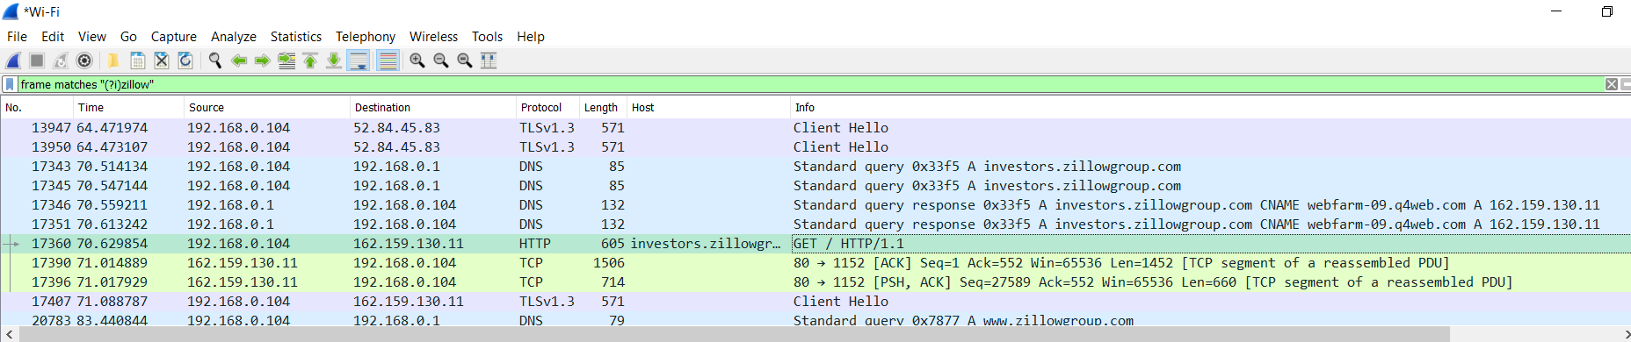

Select the packet and expand the Hypertext Transfer Protocol tab right click on it go to Protocol Preferences and check Allow subdissector to resemble TCP stream.

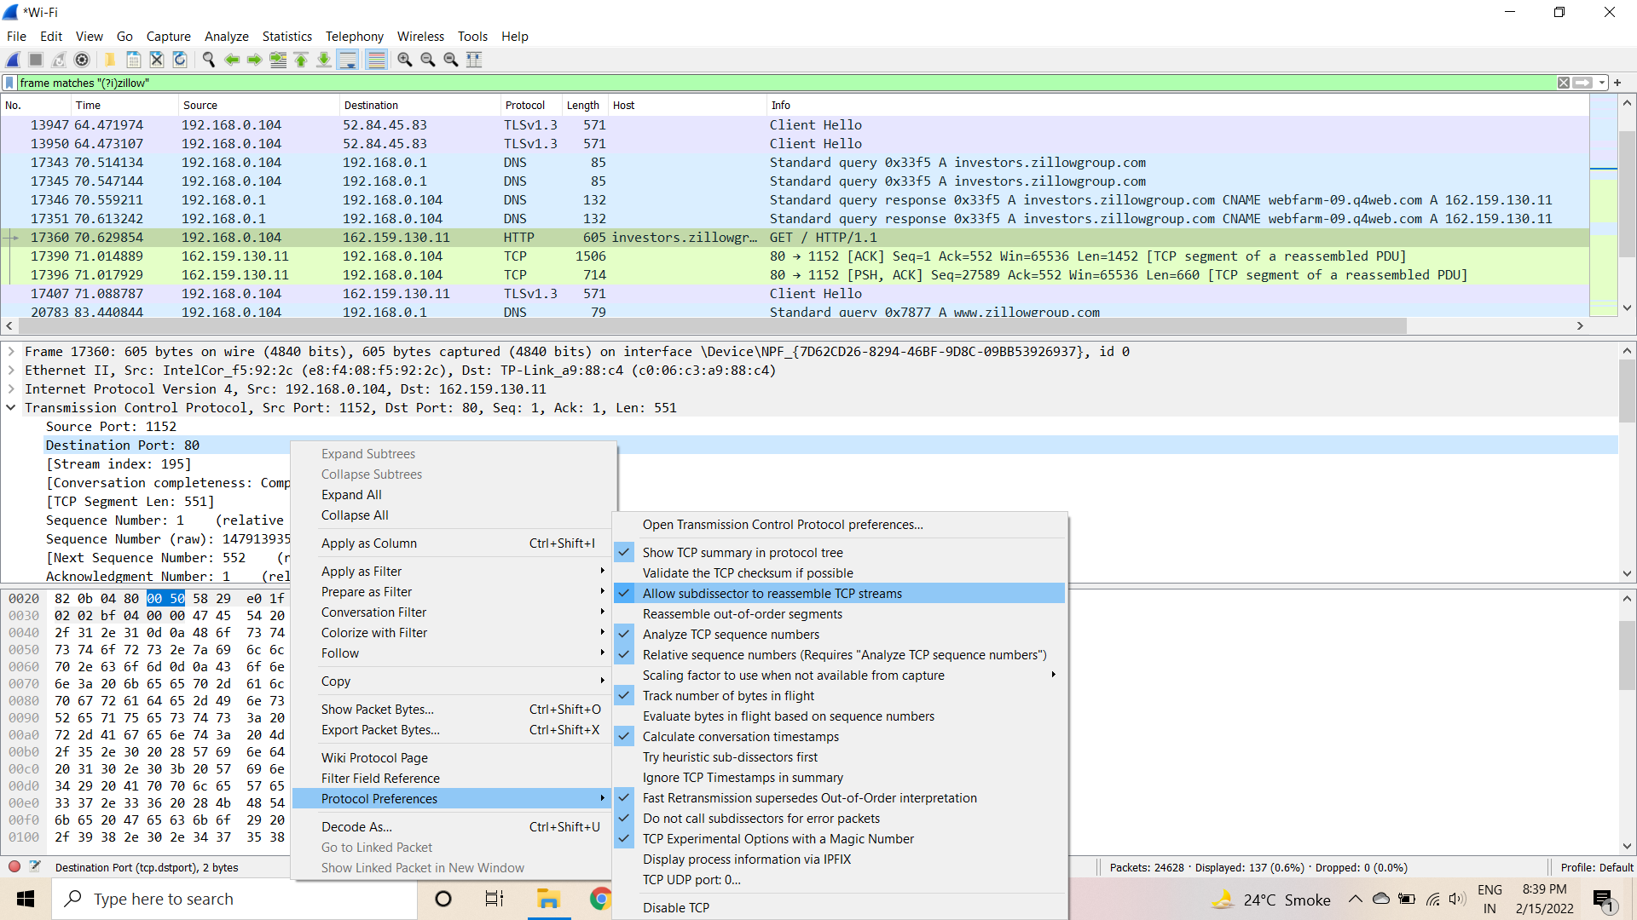

Now go to file and select Export Objects > HTTP. It will save all objects from the packet.

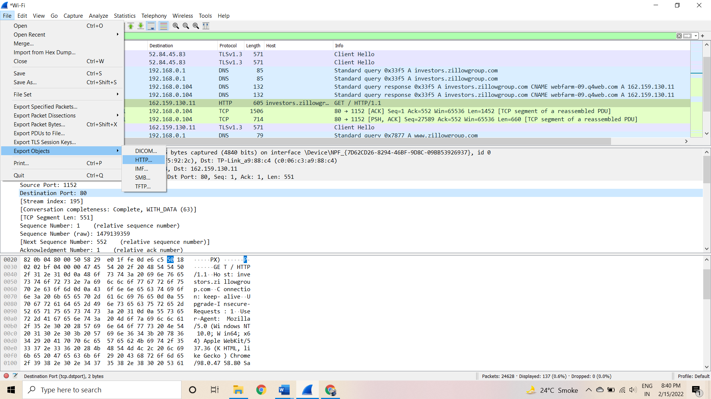

Click on save all.

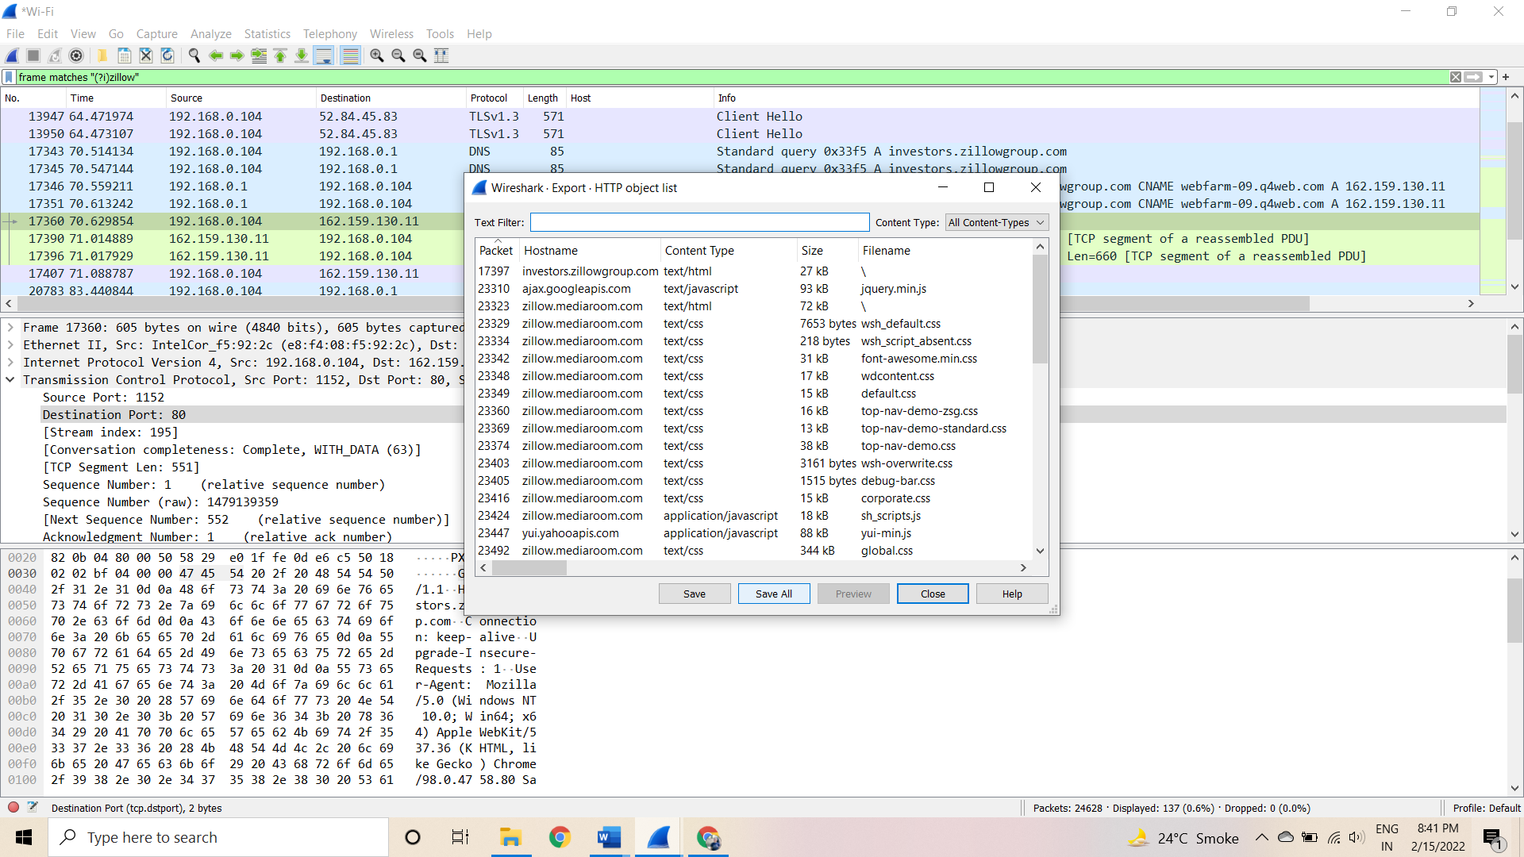

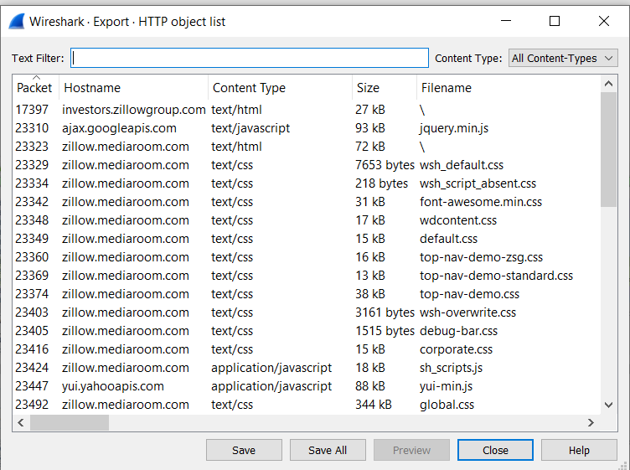

After saving all files in a directory and we found a swf file with name Zillow. After opening the flash file, we saw that Zillow was trying to learn saxophone.

## How many web servers are running Apache?

**Analysis –** The web server name can be retrieved from HTTP response header. So will apply filter http. response and we can see all http response packets.

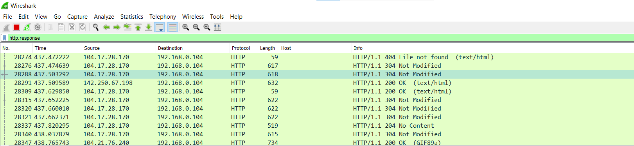

Now set the server header as column select any packet and right click on it then select apply as Column.

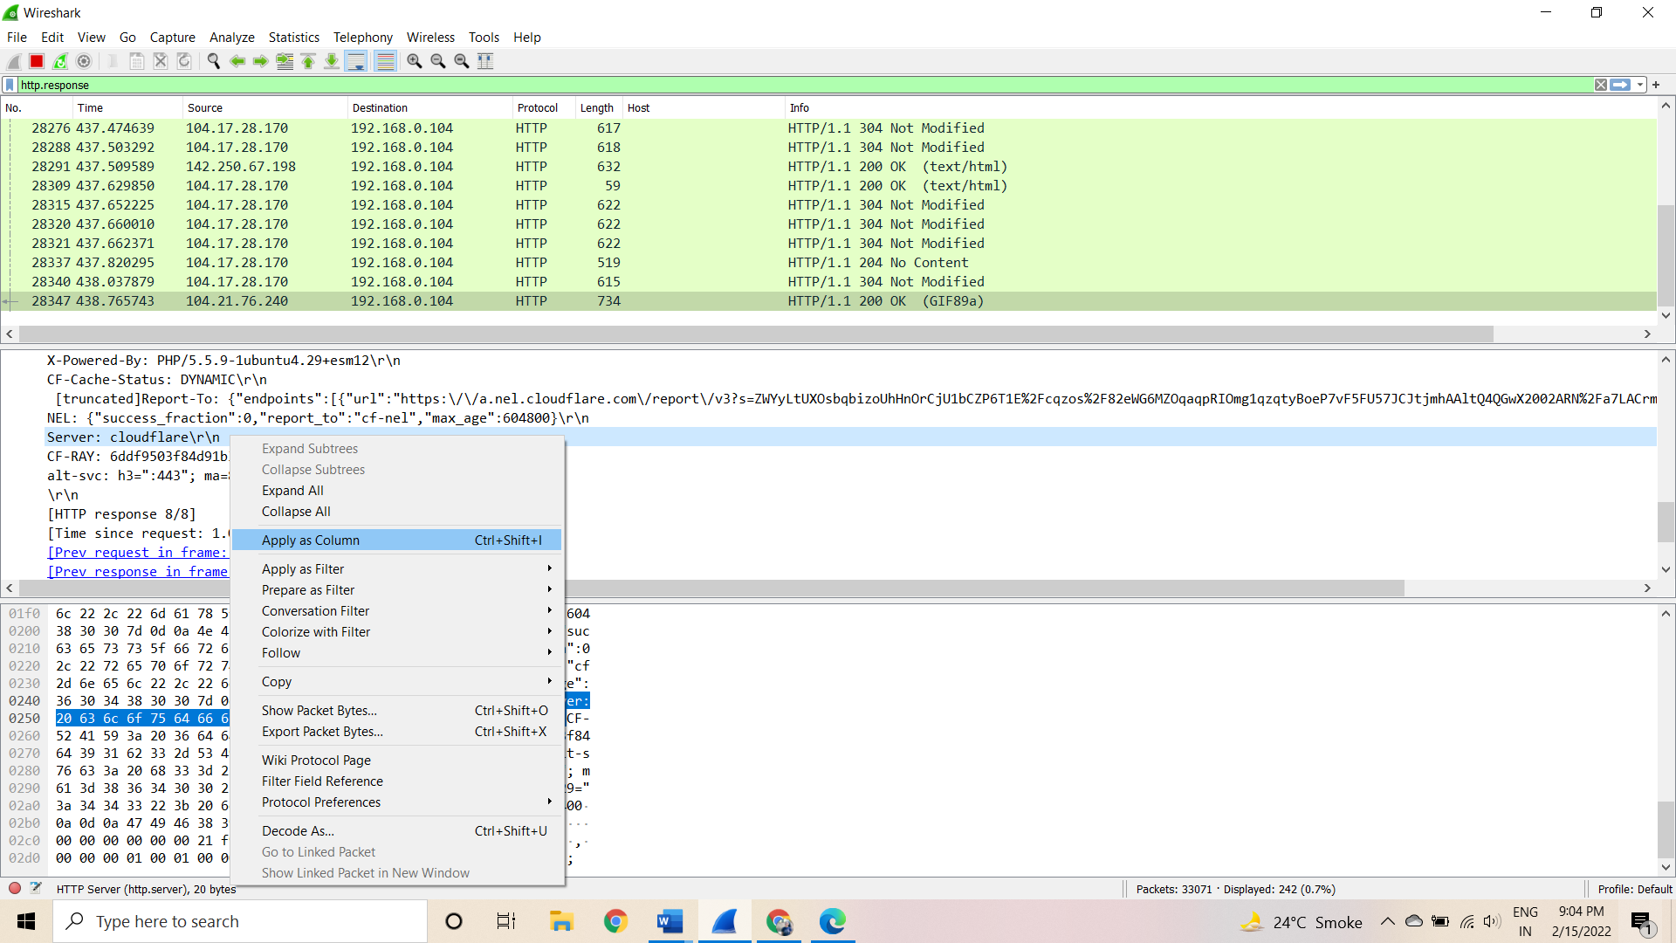

Now can see the server column where all server name is showing.

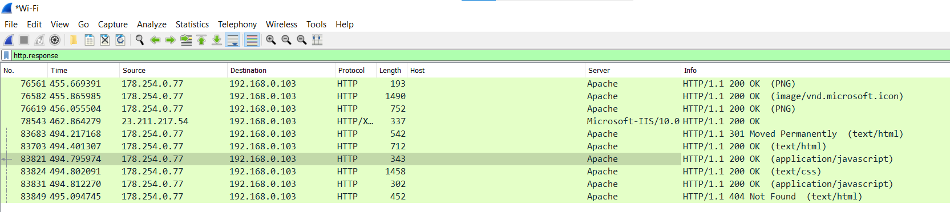

Now we have to check how many Apache packets are there we can’t count manually for each packet so we will apply another filter http.server contains “Apache”

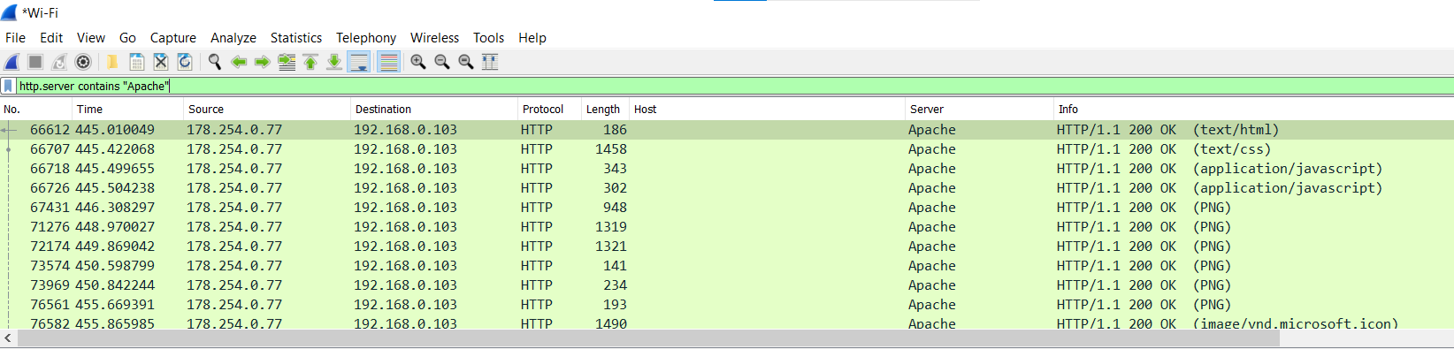

After applying filter go to Statistics > Endpoints

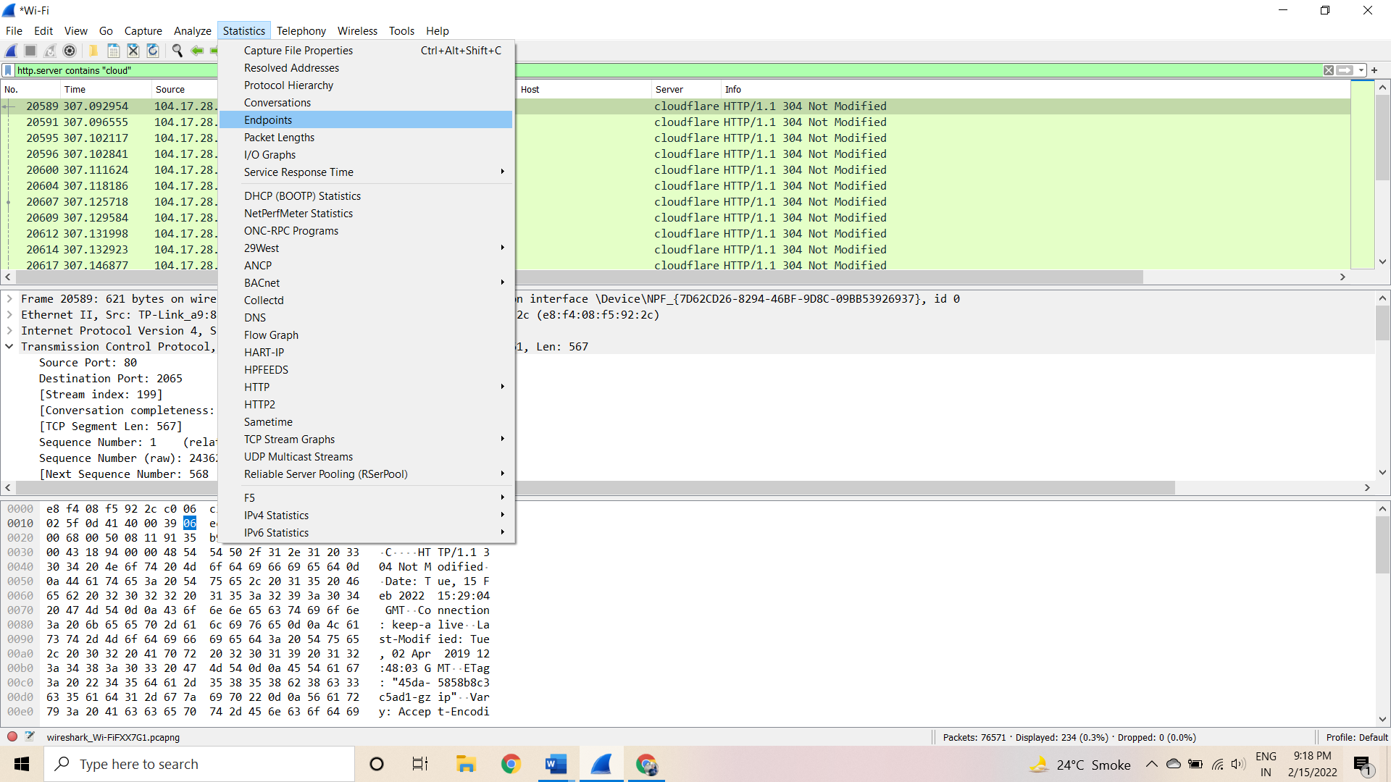

It will show all connections

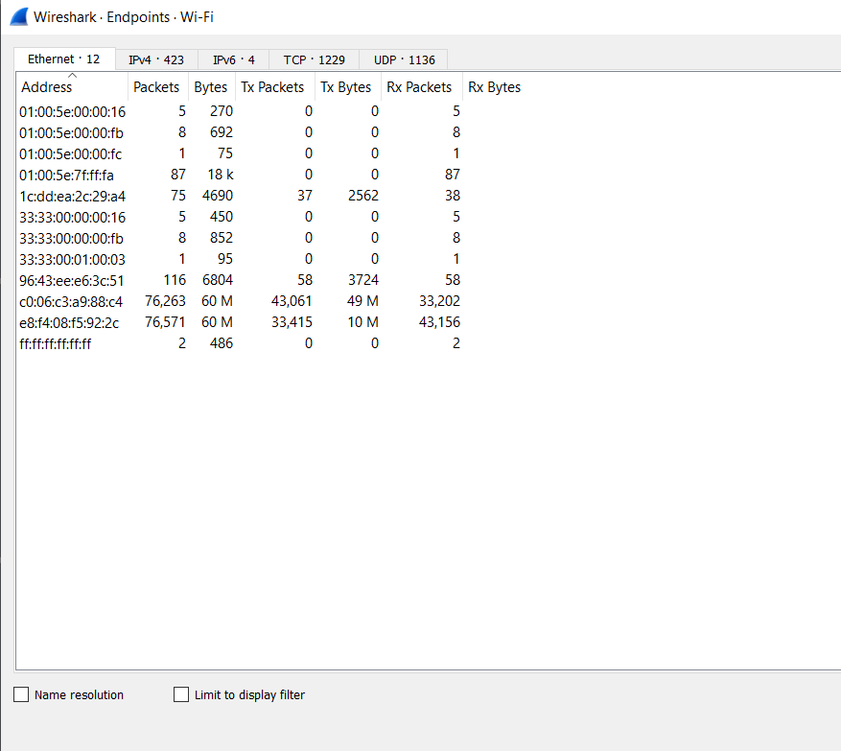Check the limit to display filter then it will show the actual Apache connections. Now there are showing 22 connections but will exclude 192.168.1.71 because it is client’s IP not a server IP so there are actual 21 Apache servers.

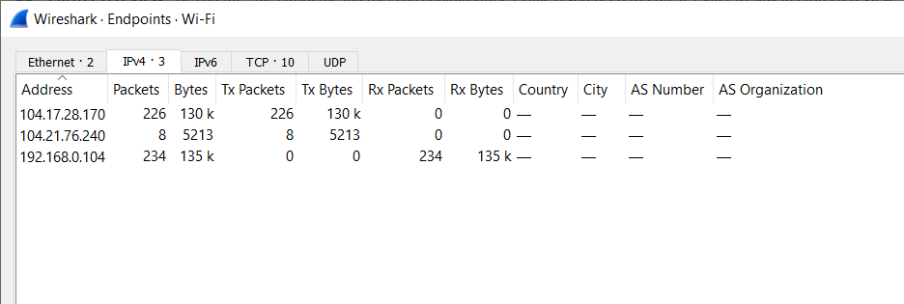

# **Practical 6**

**AIM :- Using Sysinternals tools for Network Tracking and Process Monitoring :**

* Check Sysinternalstools
* Monitor LiveProcesses
* CaptureRAM
* Capture TCP/UDP packets
* Monitor HardDisk
* Monitor VirtualMemory
* Monitor CacheMemory

**Check Sysinternals tools :**Windows Sysinternals tools are utilities to manage, diagnose, troubleshoot, and monitor a Microsoft Windows environment.

The following are the categories of Sysinternals Tools:

* 1. File and DiskUtilities
  2. NetworkingUtilities
  3. ProcessUtilities
  4. SecurityUtilities
  5. System InformationUtilities
  6. MiscellaneousUtilities

**Monitor Live Processes : (Tool: ProcMon) ToDo:**

1. Filter (Process Name or PID or Architecture,etc)
2. ProcessTree
3. Process ActivitySummary
4. CountOccurrences

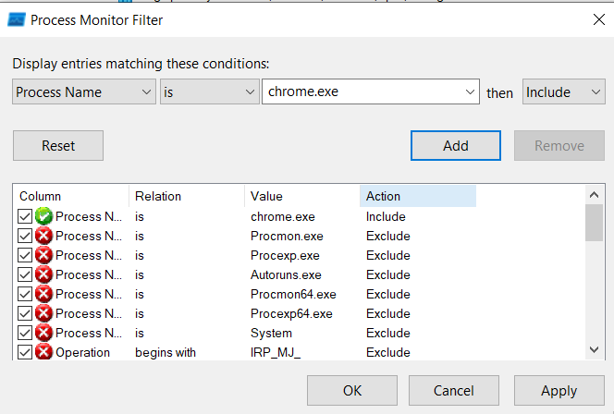

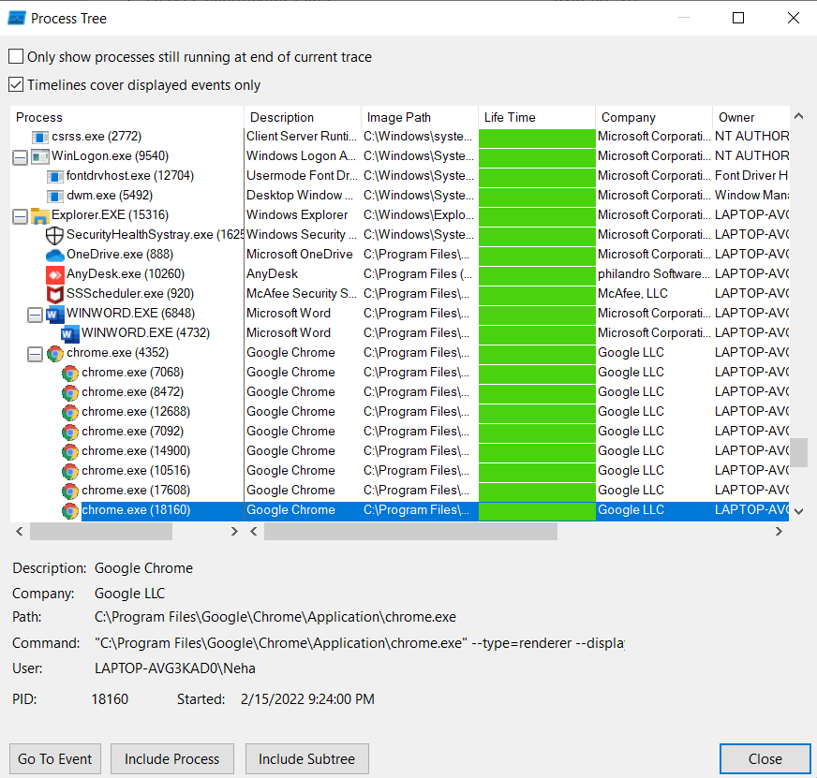

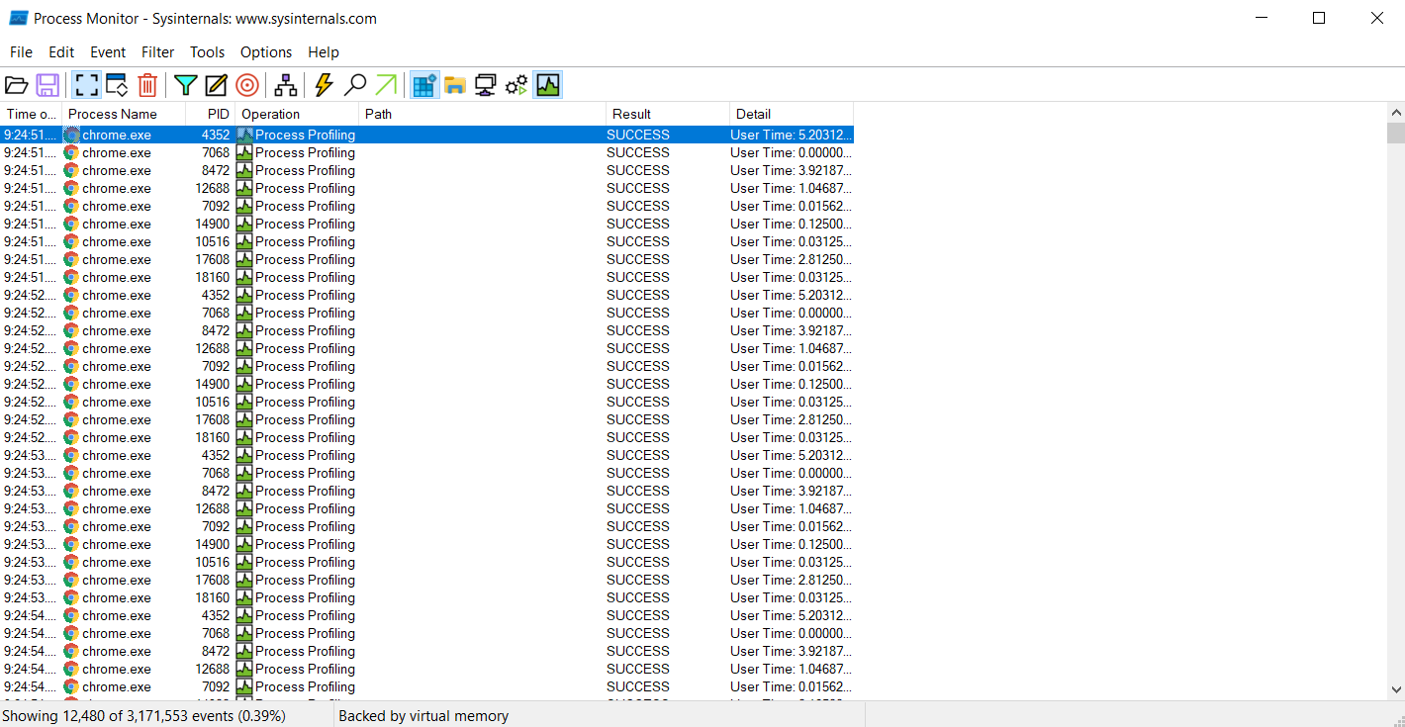

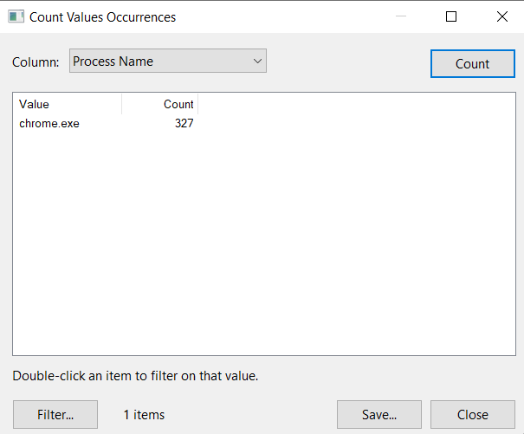

**Capture RAM (Tool:RAMCapture)**

**To Do:**

Click Capture

Creates a .mem file of the system memory (RAM)utilized.

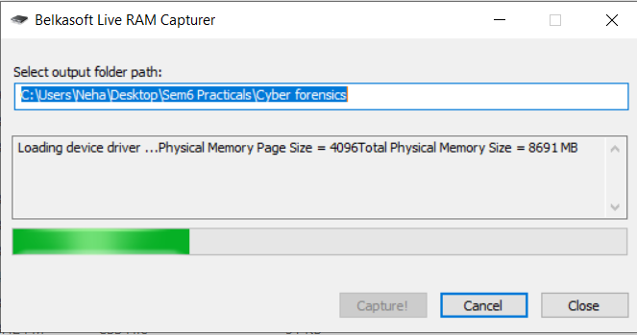

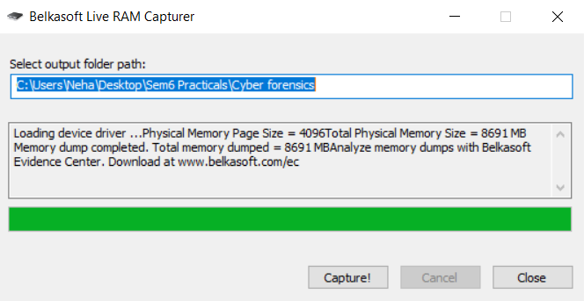

**Capture TCP/UDP packets (Tool: TcpView):**

**To Do:** Save to .txtfile. as Whois

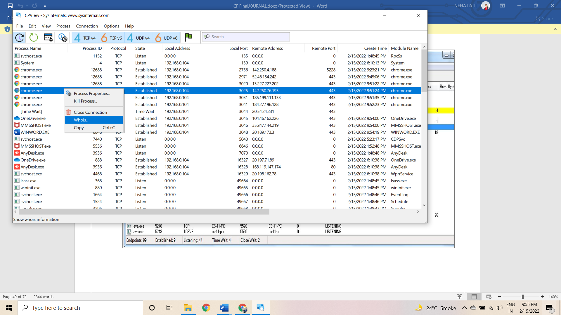

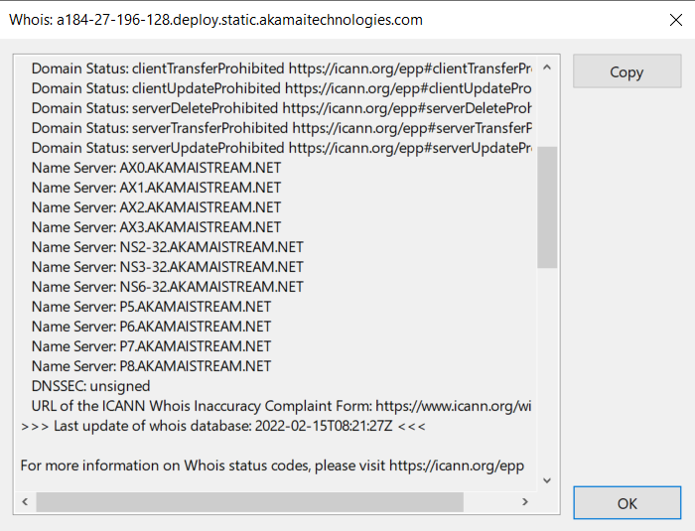

**Monitor Hard Disk (Tool: DiskMon): To Do:**

1. Save to .logfile.
2. Check operations performed in the disk as per time and sectors affected.

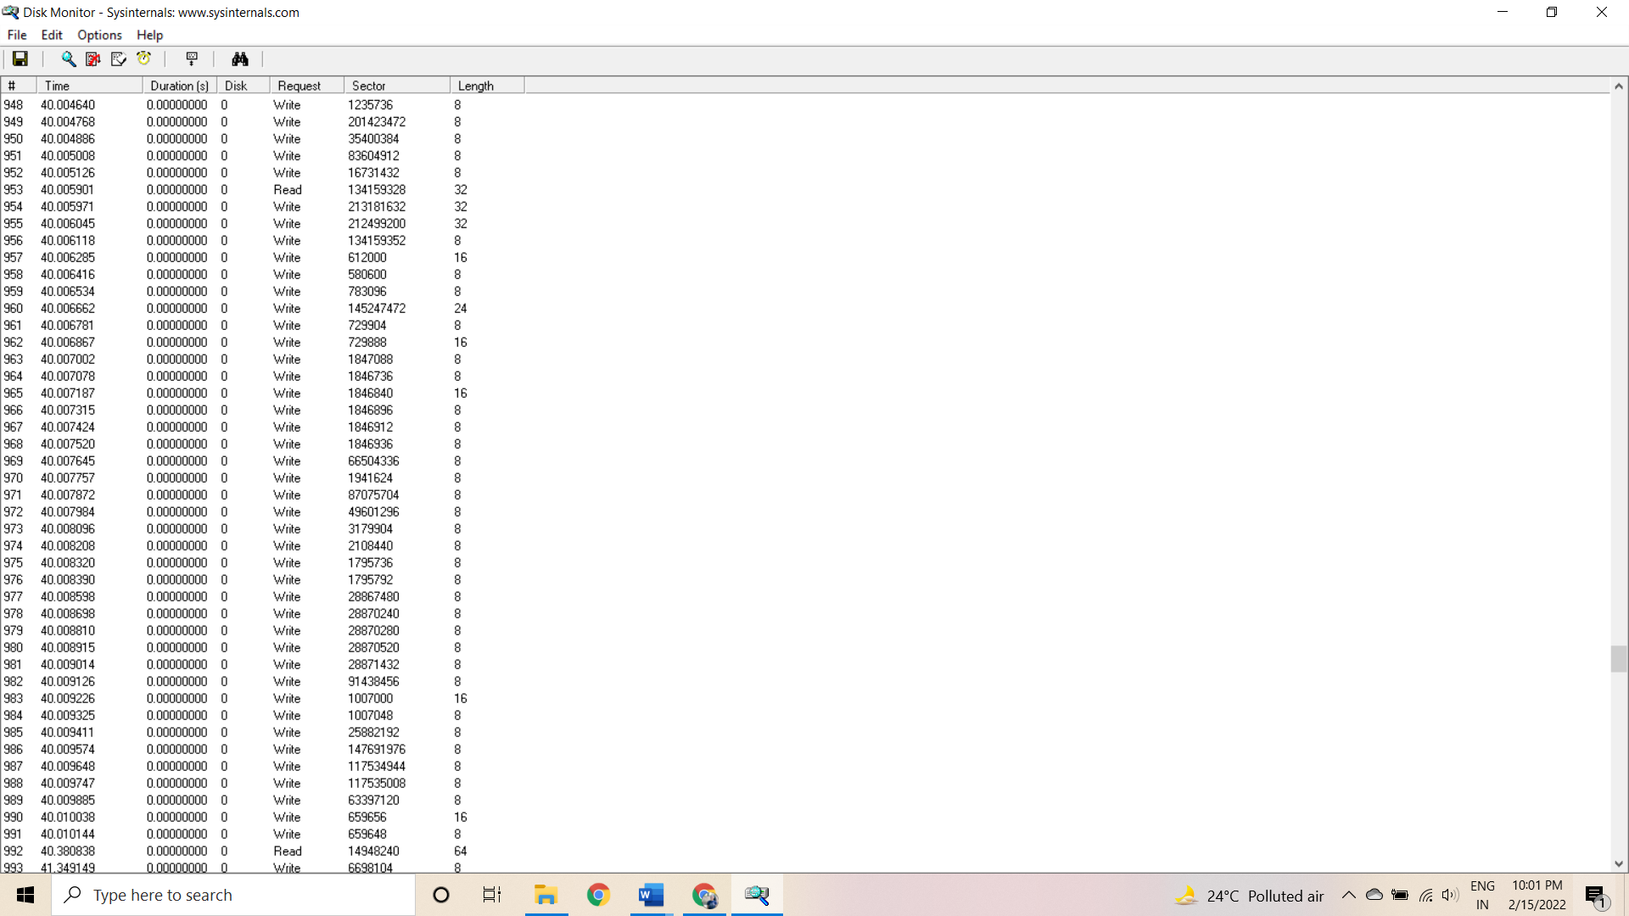

**Monitor Virtual Memory ( Tool : VMMAP):**

**To Do:** Options – Show Free & Unusable RegionsFile-> Select Process e.g.chrome.exeSave to .mmpfile.

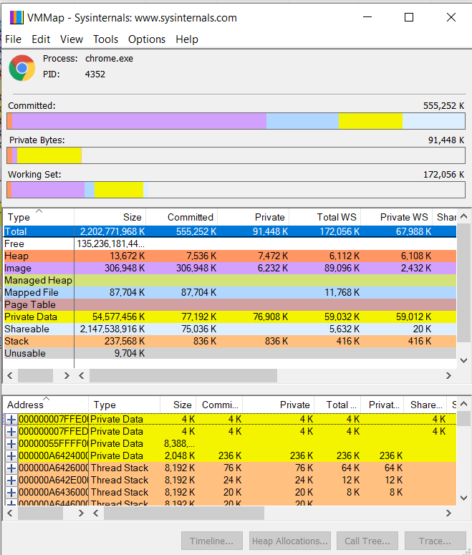

**Monitor Cache Memory (Tool:RAMMap) TO DO :**

* 1. Save to .RMPfile.

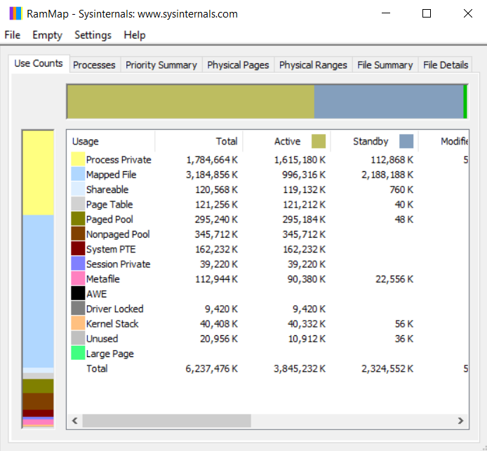

**Practical 7**

**AIM: Recovering and Inspecting deleted files**

- Check for Deleted Files

- Recover the Deleted Files

- Analyzing and Inspecting the recovered files

Step 1 start autopsy from desktop Now create on New Case.

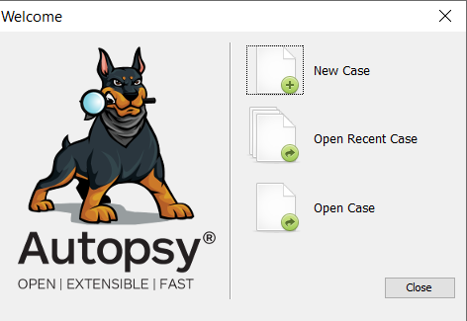

Step 2: Enter the New case Information and click on Next Button.

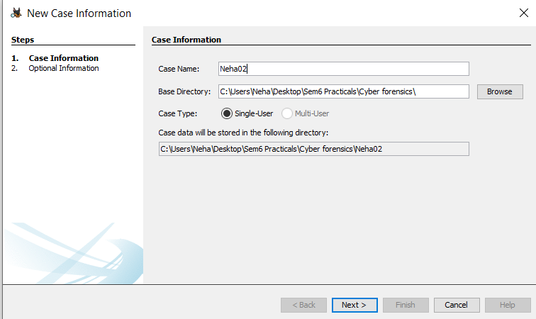

Step 3: Enter the additional Information and click on Finish.

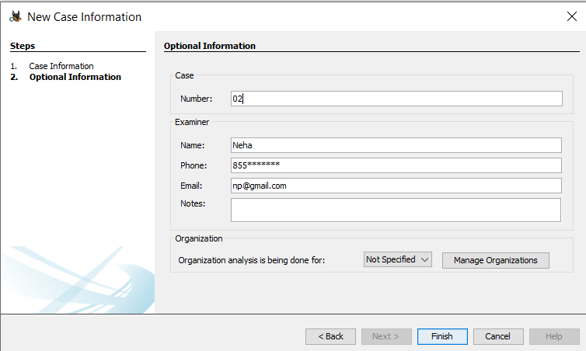

4. Now Select Source Type as Local disk and Select Local disk form drop down list and click on Next.

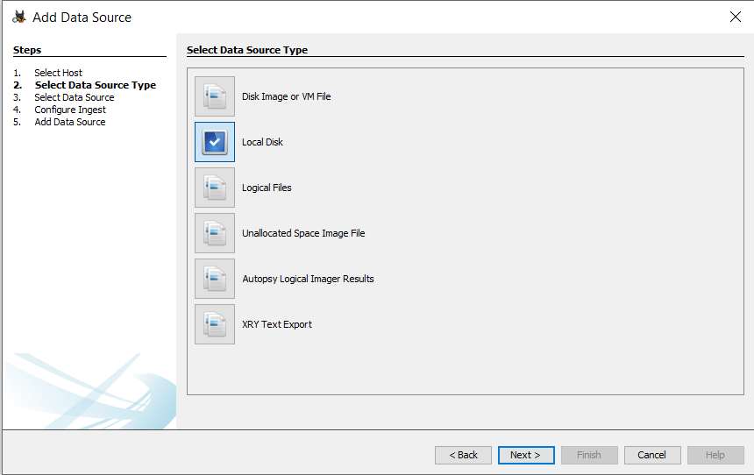

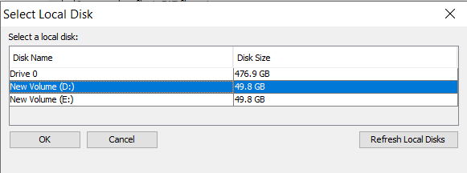

Step 5: Click on Next Button.

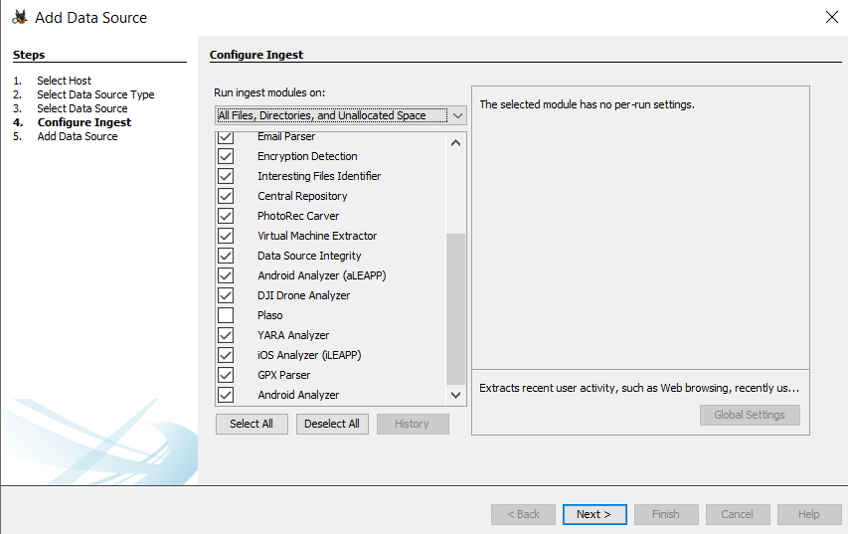

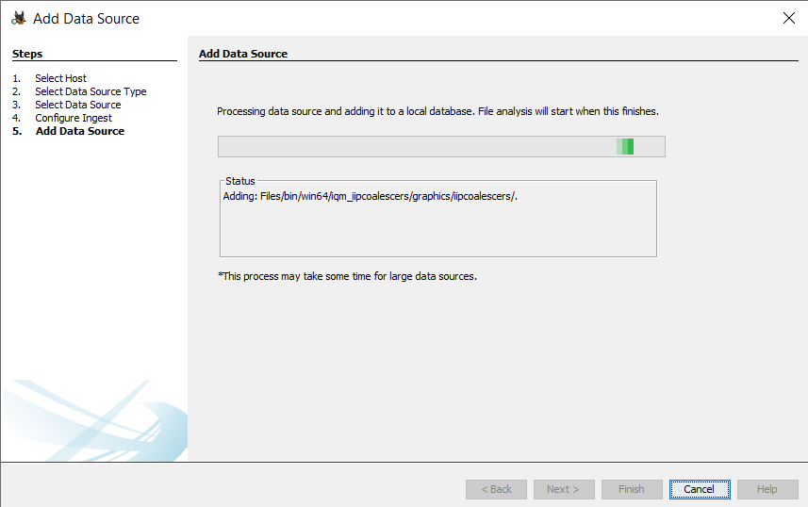

Step 6: Now click On Finish.

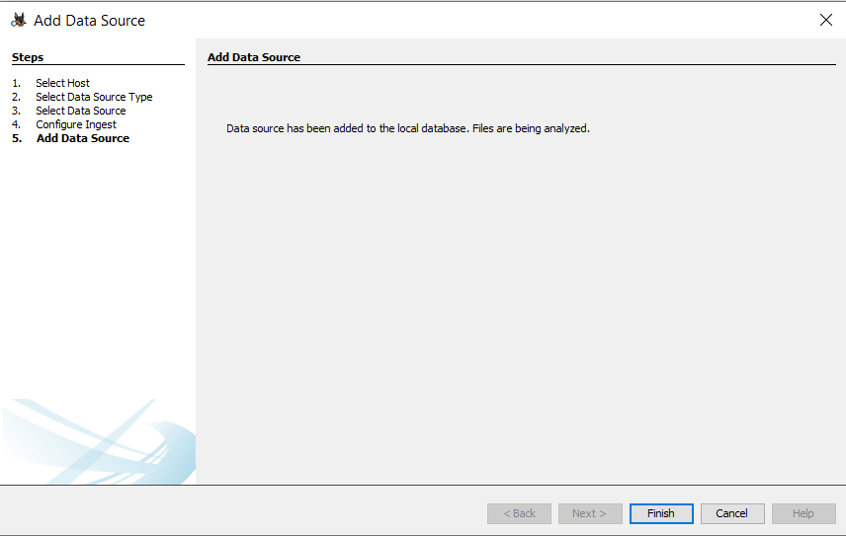

Step 7: Now Autopsy window will appear and it will analyzing the disk that we have selected.

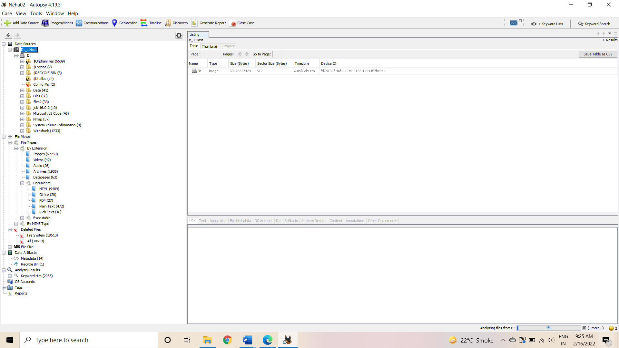

Step 8: All files will appear in table tab select any file to see the data.

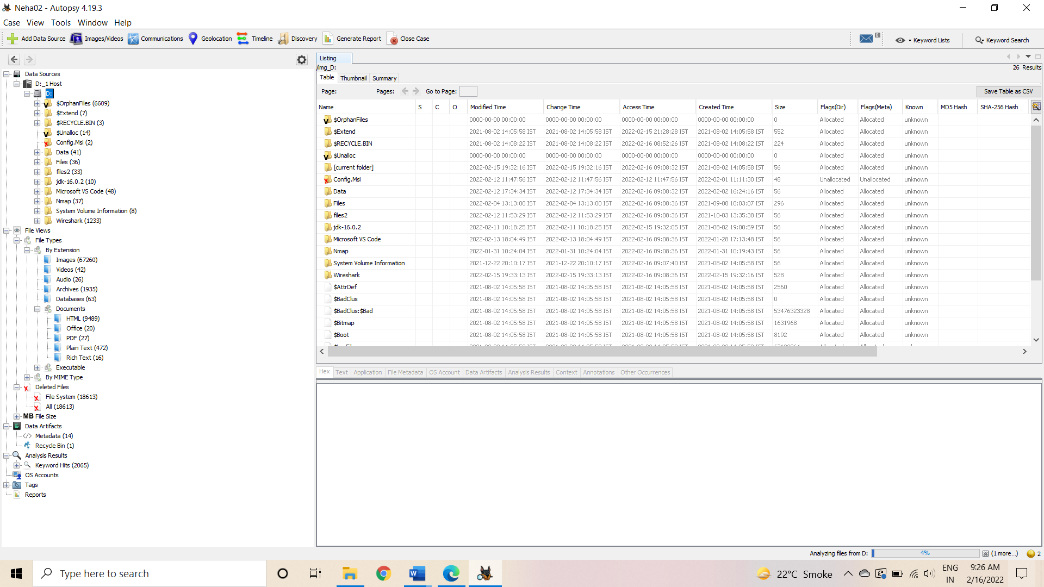

Step 9:Expand the tree from left side panel to view the document files.

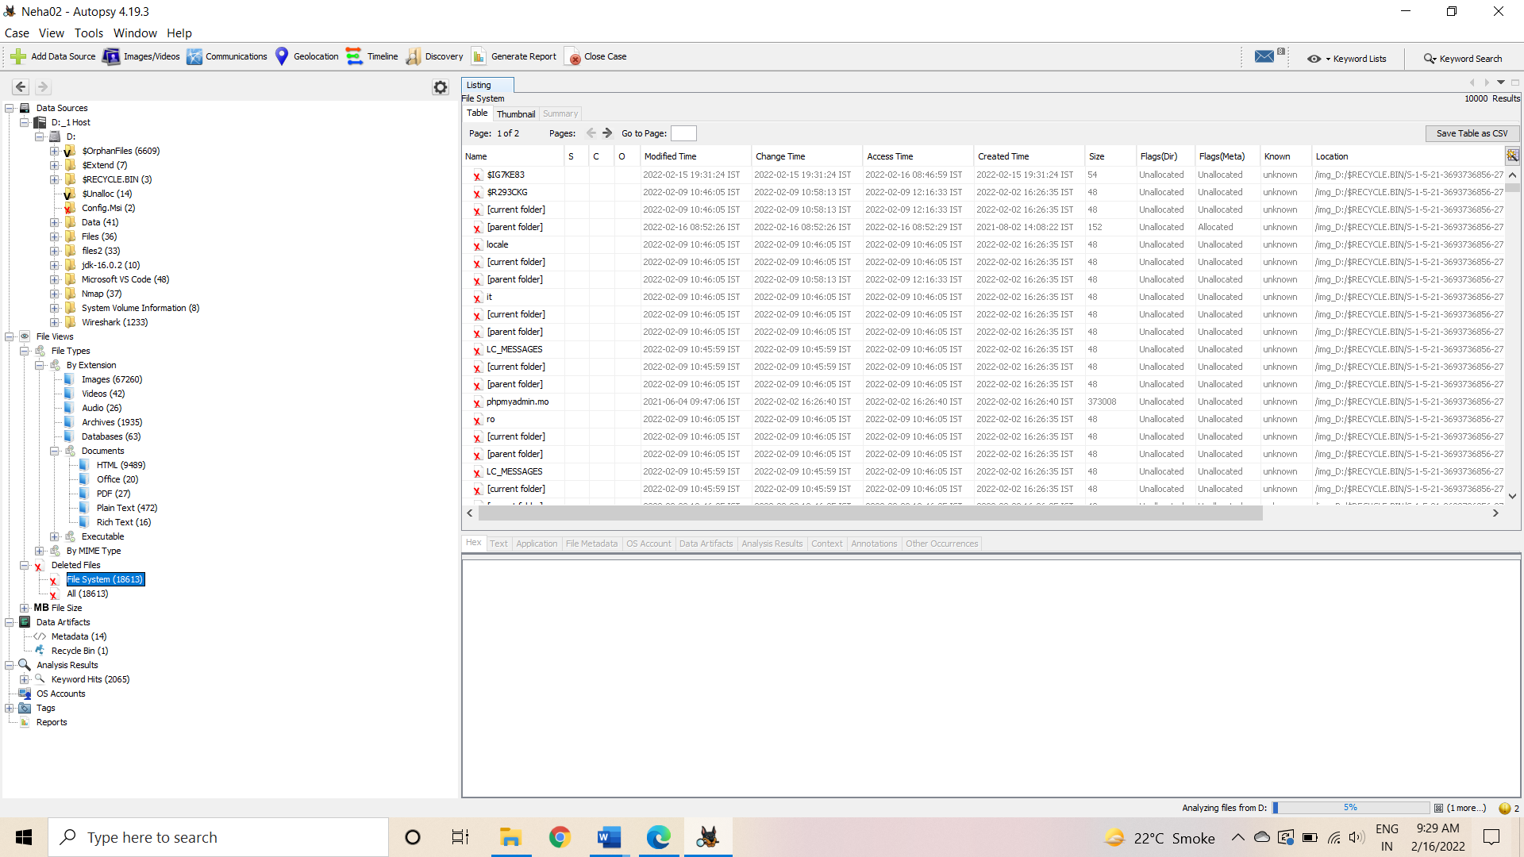

Step 10: To recover the file, go to view node-> Deleted Files node , here select any file and right click on it than select Extract Files option.

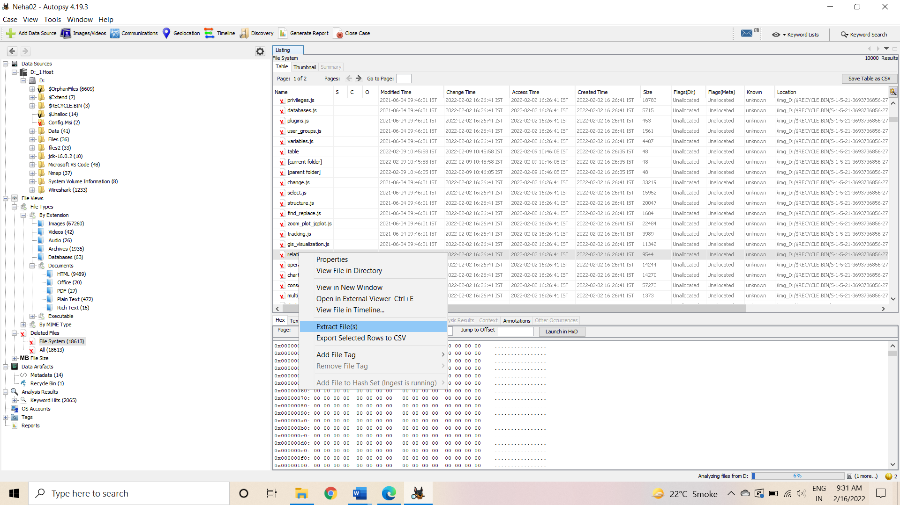

Step 11: By default Export folder is choose to save the recovered file.

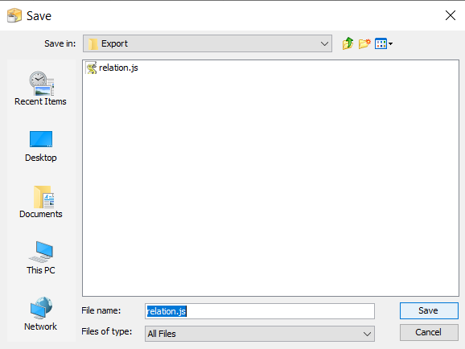

Step 12 : Now Click on Ok.

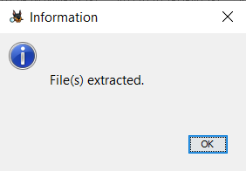

Step 13: Now go to the Export Folder to view Recover file.

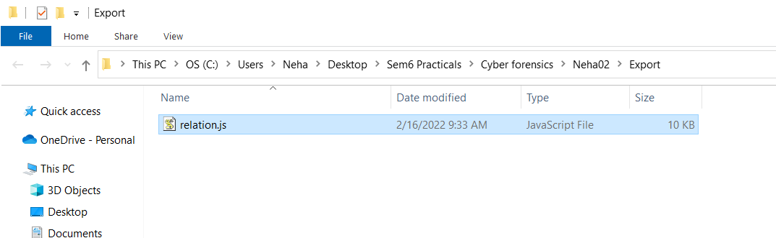

Step 14: Click on Generate Report from autopsy window and Select the Excel format and click on next.

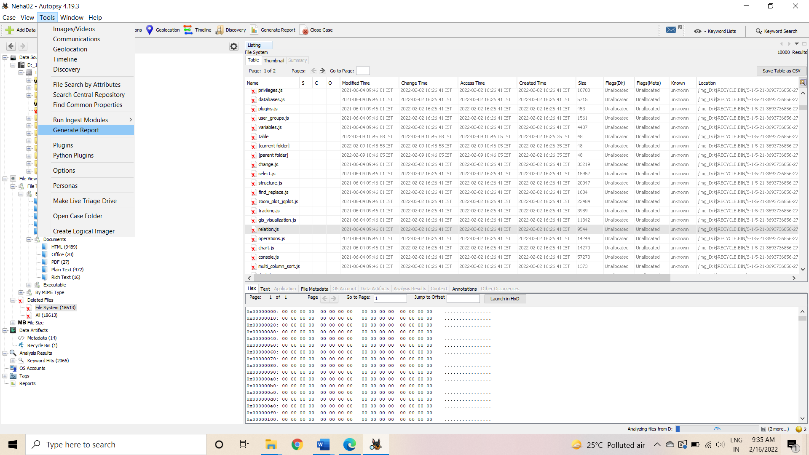

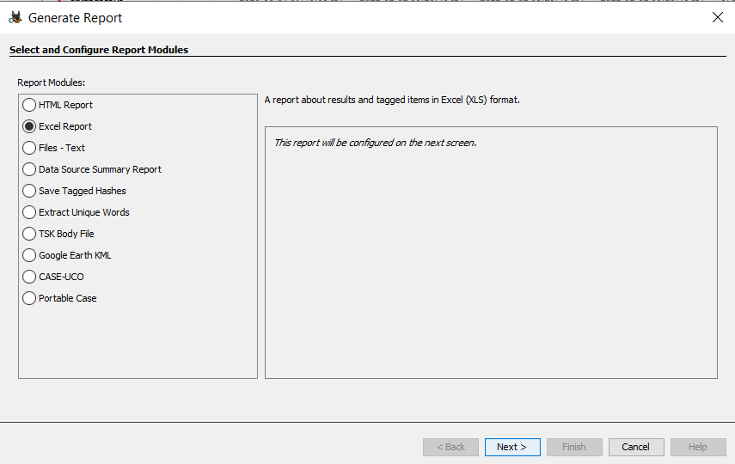

Step 15: Now Report is Generated So click on close Button .we can see the Report on Report Node.

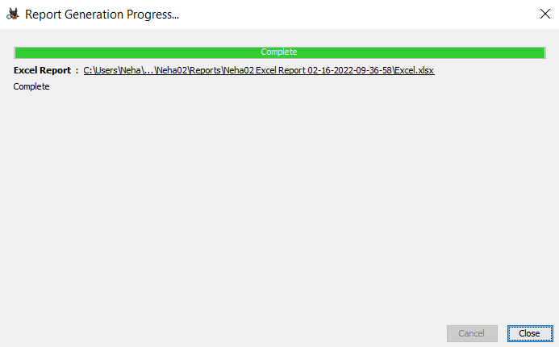

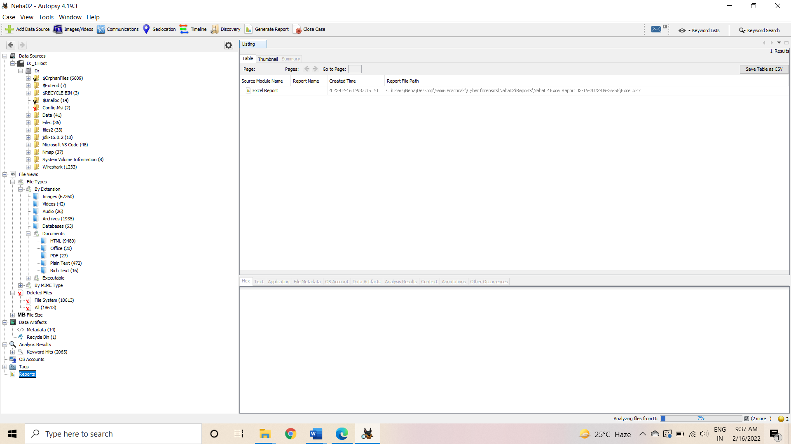

Step 17: Now open the Report folder and Open Excel File.

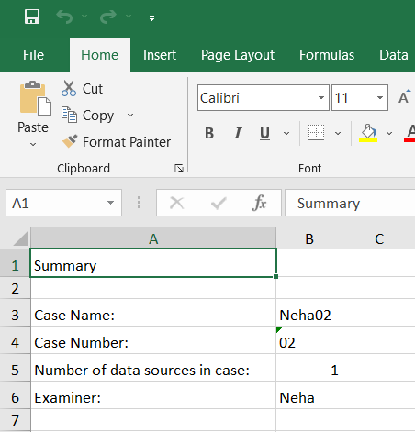

**Practical 8**

**AIM : Acquisition of cell phones and mobile phones**

**Solution:**

# To get information from android device is easy.

# Go to menu settings>>About phone>>Software and hardware information.

# You will get the information like firmware version, baseband version, kernel version, build number, software number etc.

# In this case, we use a host Windows and android software development kit. The SDK helps developers build test and debug applications to run on Android.

# The method to get serial number of an Android device is the following:

# Download from web the SDK package of if you will find it in android studio folder if you have installed android studio on your desktop.

# If you don’t have the SDK File and after download, create a folder called ANDROIDSDK and unzip the zip file you download.

# Connect your android device via USB cable.

# In the CMD, browse the ANDROIDSDK folder, tools and we run adb device command.

# If all works properly, a list of linked device will appear with a serial number and if not then check the proper working of driver and the USB debugging enabled.

# Output:

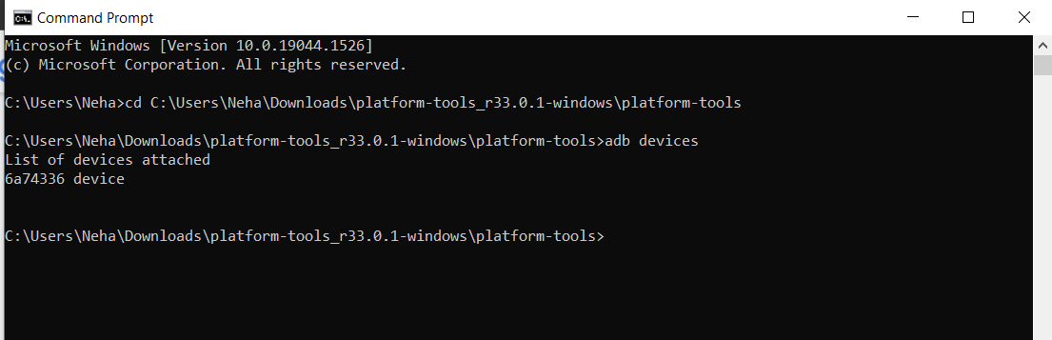

**Practical 9**

**AIM: Email Forensics –**

**1. Mail Service Providers**

# Step 1 : Find MX Record.

# MX records points a domain’s incoming email provider responsible for processing those messages.

# Go to http://www.misk.com/tools/ # dns

# Enter your domain name.

# Press Enter on your keyboard. A list of all dns records for the name will appear.

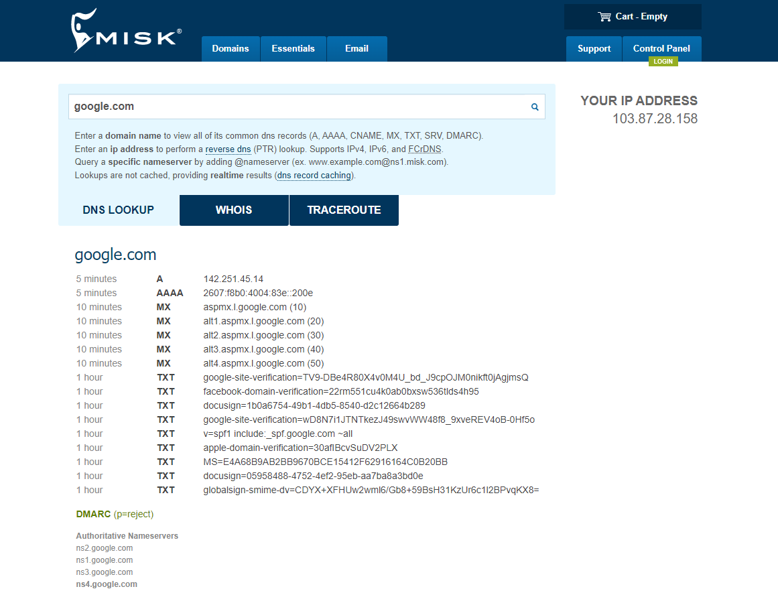**2. IP WHOIS:**

In most cases, the MX record name from step 1 will indicate your email provider and you can stop there. However, the domain has custom MX records that are based on the domain itself. In those cases, you will need to perform a dns lookup on the hostname to find the email providers address.

# Copy the hostname for the step 1

# Go the same site and enter the copied hostname.

# Press enter on your keyboard.

# Look for A record.

# Go to whois tab and enter the ip address you just copied.

# Press enter .

# The IP address whois record will appear.

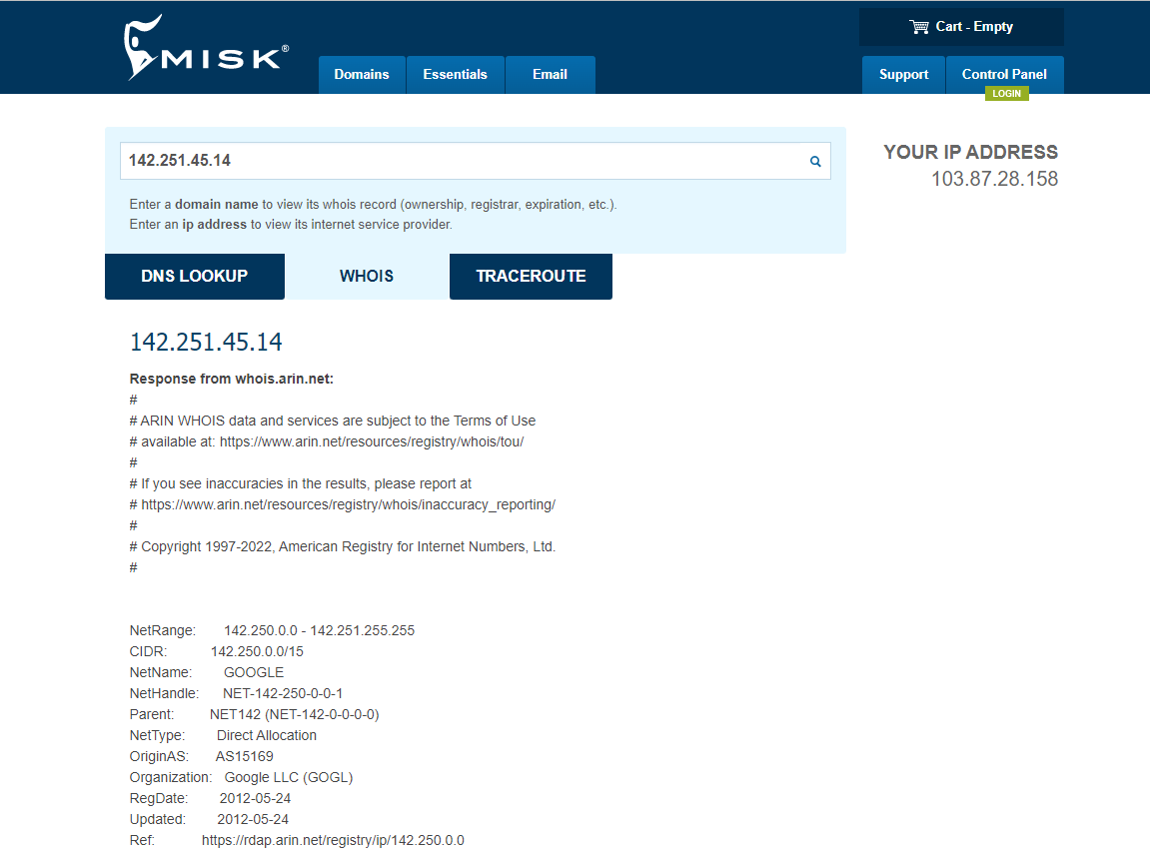

**3. Email protocols –**

# On your computer, open Gmail.

# In the top right corner, click settings.

# Click on forwarding and POP/IMAP tab

# Now you can see that which protocol your email is using. Here it is using POP and IMAPs

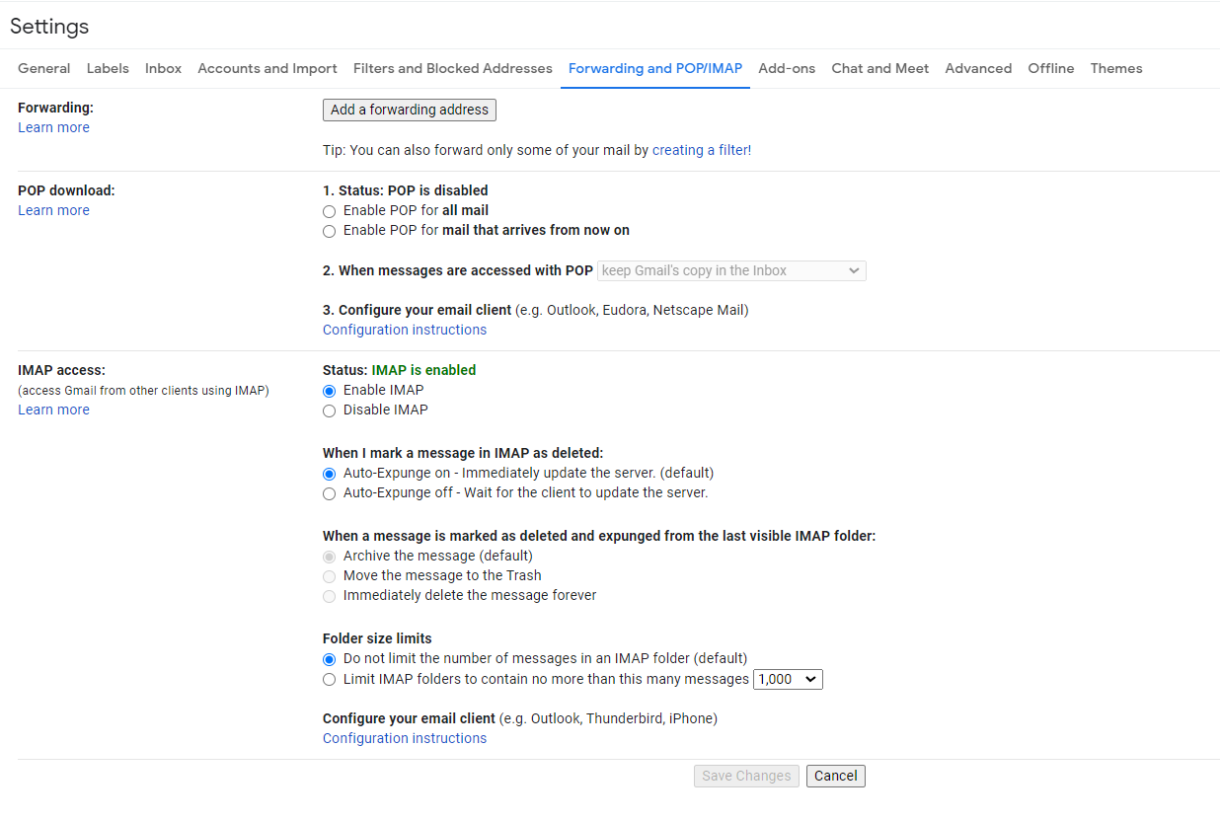

**4. Recovering emails –**

1. To recover the emails here we are using EaseUS recovery tools.

Run the email recovery software.

2. Click on scan to let the software scan and find the lost emails.

Step 2:

1. Find the lost emails .

2. Deleted files: If you accidentally delete the email files, they will appear.

3. Lost files: All lost files will appear here.

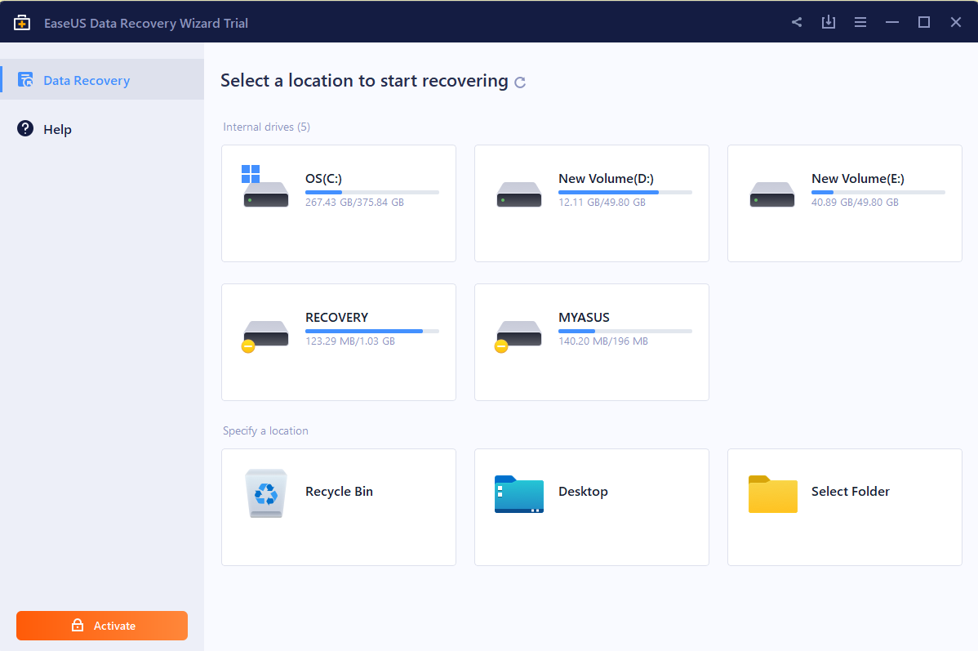

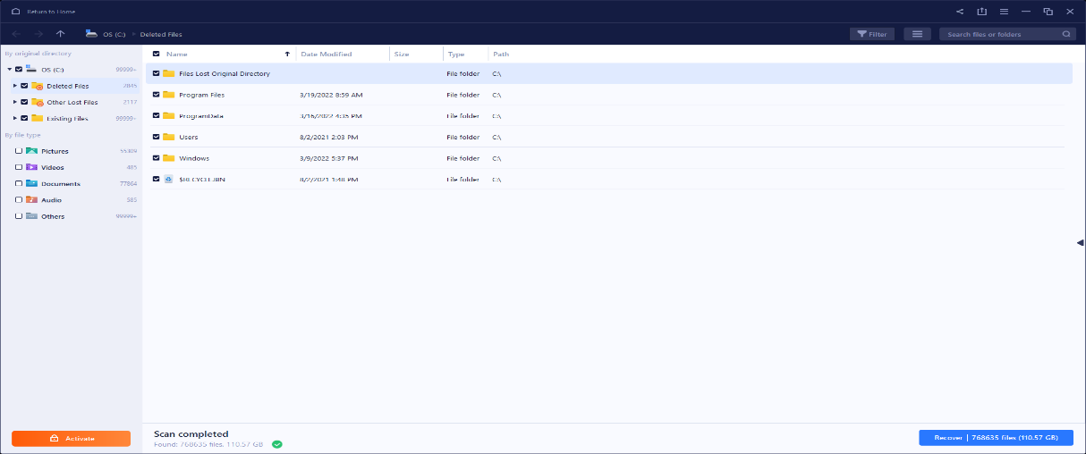

**4. Analyzing email headers.**

# Open the email you want to analyze the header for.

# Next to reply, click on the down arrow.

# Click show original.

# Copy the text on the page.

# Open the message header tool. (<http://toolbox.googleapps.com/messageheader>)

# Paste the header the paste box.

# Then click on analyse the above header.

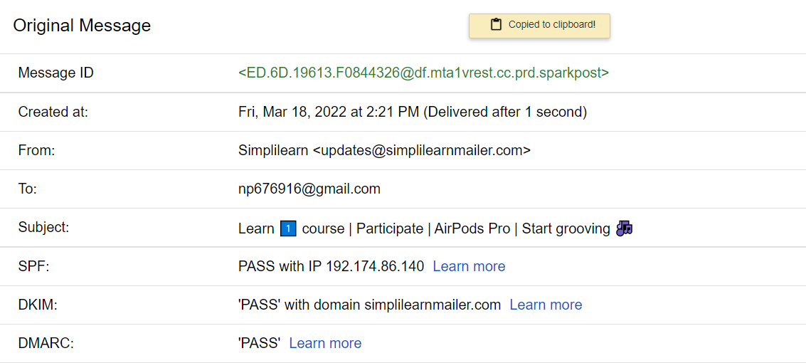

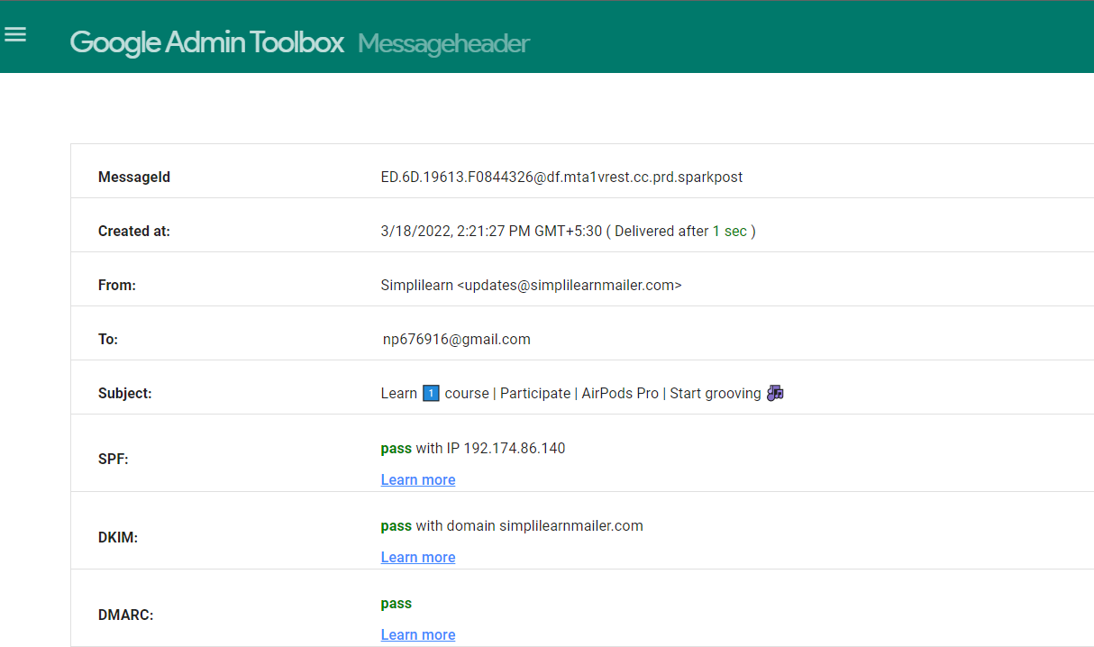

**Practical 10**

**AIM: Web Browser Forensics**

**Web browser working**

1. A web browser is an application software installed on computer to provide access to world wide web.
2. It fetches the web pages from the server along with necessary files like images, flashes, videos etc.
3. All you have to do is simply type the URL of a web page in the address bar and the browser will bring the web page on your screen.
4. The browser’s main functionality is to fetch the files from the server and to display them on the screen.
5. It basically displays html files containing images, pdf, videos, flashes etc.
6. It is a group of structured codes that perform plenty of tasks to display a webpage on the screen.
7. **Forensic activities on browser:**
8. Everyone uses web browser to surf the internet.
9. Important evidence could be collected from the web browser such as

* Cache
* History
* Cookies
* Download list

1. There are researches studies and tools for the aid of web browser log file analysis.
2. We can find out the last activity performed on the internet.
3. **Cache/Cookies analysis**
4. Chrome
5. From the chrome menu in the top right corner, select settings.
6. At the bottom of the page, click on show advanced settings.
7. Under privacy, select content settings….

* To manage cookie settings, check or uncheck the option under cookies.
* To view or remove individual cookies, click all cookies and site data..and hover the mouse over entry. Select the X that appears next to the cookies to remove it.
* To delete all cookies click All cookies and site data…..and select remove all

1. Last internet activity:
2. To check the last internet ativity enter the URL:

(<http://myactivity.google.com/myactivity>)

1. You will get the activites you performed.
2. On your computer, open chrome.
3. At the top right, click on the three vertical dots.
4. Click History

